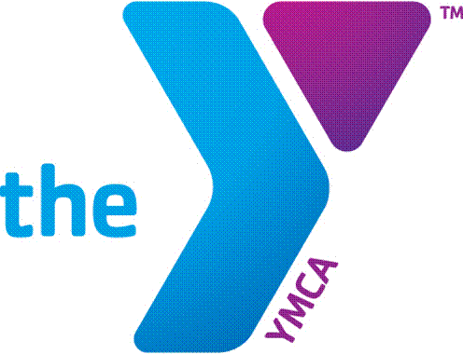

Job Opening Announcement

Position Title: Infant Toddler Lead Teacher
Position Type: Full time – non-exempt position (with benefits)
Date Posted: 08.20.19
How to apply: In person

Description:
The YMCA of Marquette County is hiring for a full time non-exempt position Infant Toddler Teacher for the YMCA Early Childhood Development Program in Marquette. This position is responsible for organizing and leading activities designed to promote cognitive, physical, emotional and social development, in the form of games, arts and crafts, music, storytelling, and field trips.

Applicants must possess an early childhood bachelor’s degree or elementary education degree with an early childhood endorsement. Previous experience and education in early childhood development is desired.

This is a wonderful opportunity to work in a membership-based organization that promotes healthy lifestyles and the values of caring, honesty, respect and responsibility. Applicant must have excellent people skills, high energy and self-motivation!

Current YMCA Employees: Submit a completed internal transfer form to your supervisor.

External Applicants: Submit a completed YMCA Employment Application and Cover Letter to the Front Desk YMCA, 1420 Pine Street, Marquette, MI 49855. Application available at www.ymcamqt.org.

