2015 World Missions Current Facts

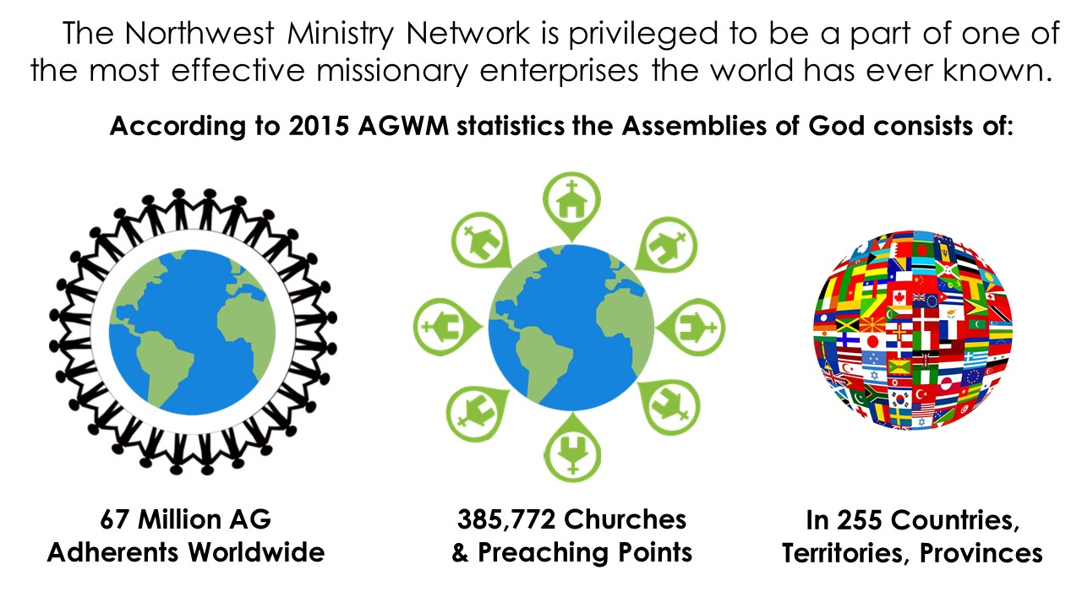

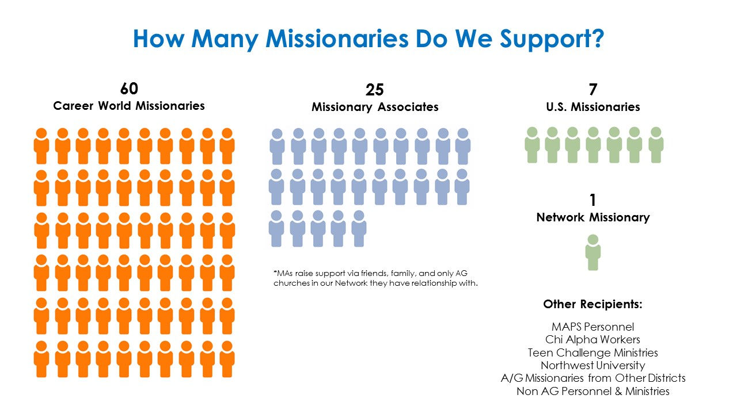

Win: We Send the Highest Number of Missionaries in our Fellowship
We celebrate the fact that the NWMN sends the highest number of missionaries in our fellowship and has historically led the fellowship in appointment of missionaries.
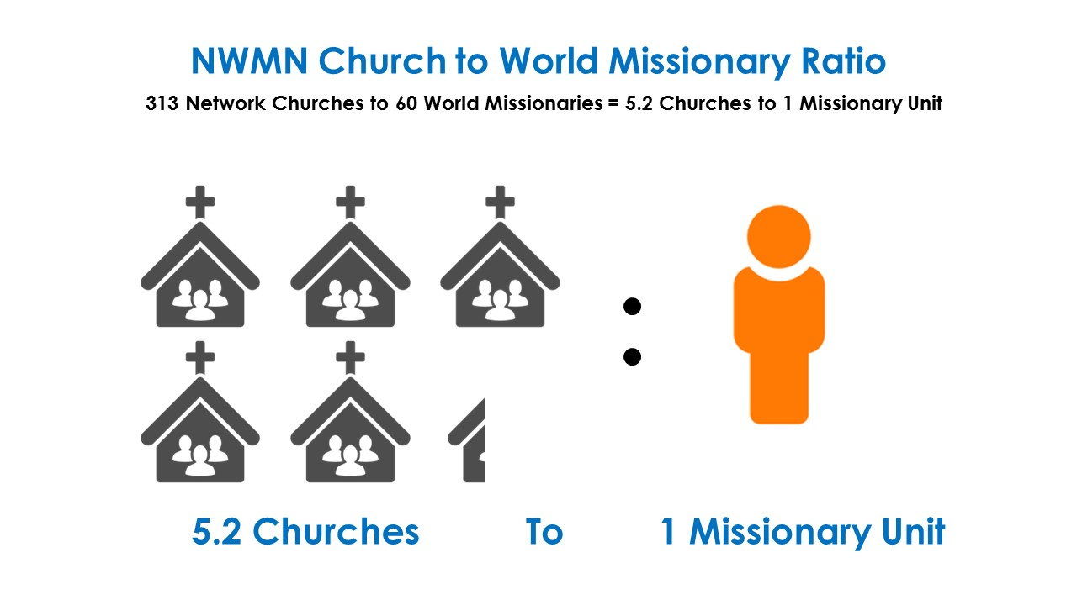

Challenge: Our Church to World Missionary Ratio is Small
The NWMN represents the highest missionary-to-church ratio in the 69 geographic and ethnic districts that comprise the U.S. Assemblies of God.

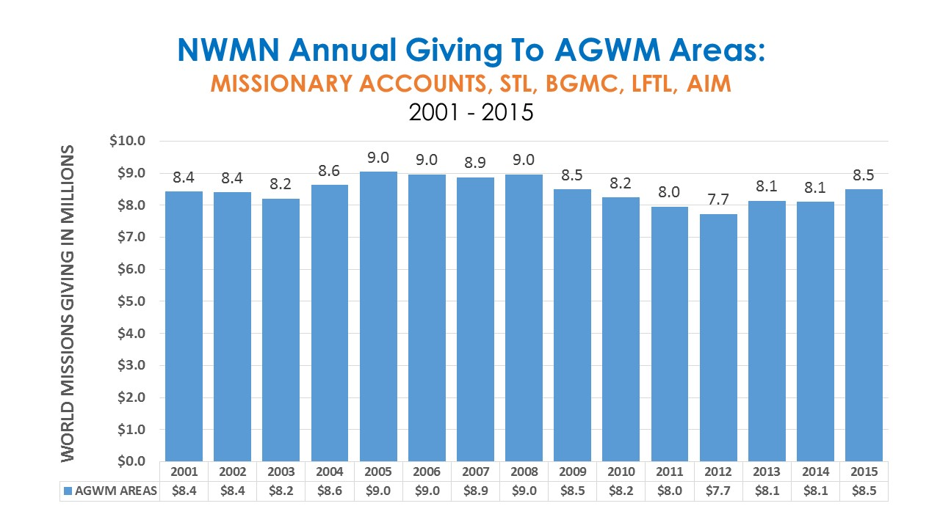

Win: We Are Climbing Out of the Recession and Giving is Increasing
2009-2012 we see a decline which would seem to correspond with the economic recession beginning in 2008 and continuing into 2010 and beyond. 2013 - 2014 we see an increase in giving back up to 8.1M and then up to 8.5M last year. Over 15 years, we average 8.4M a year in missions giving.
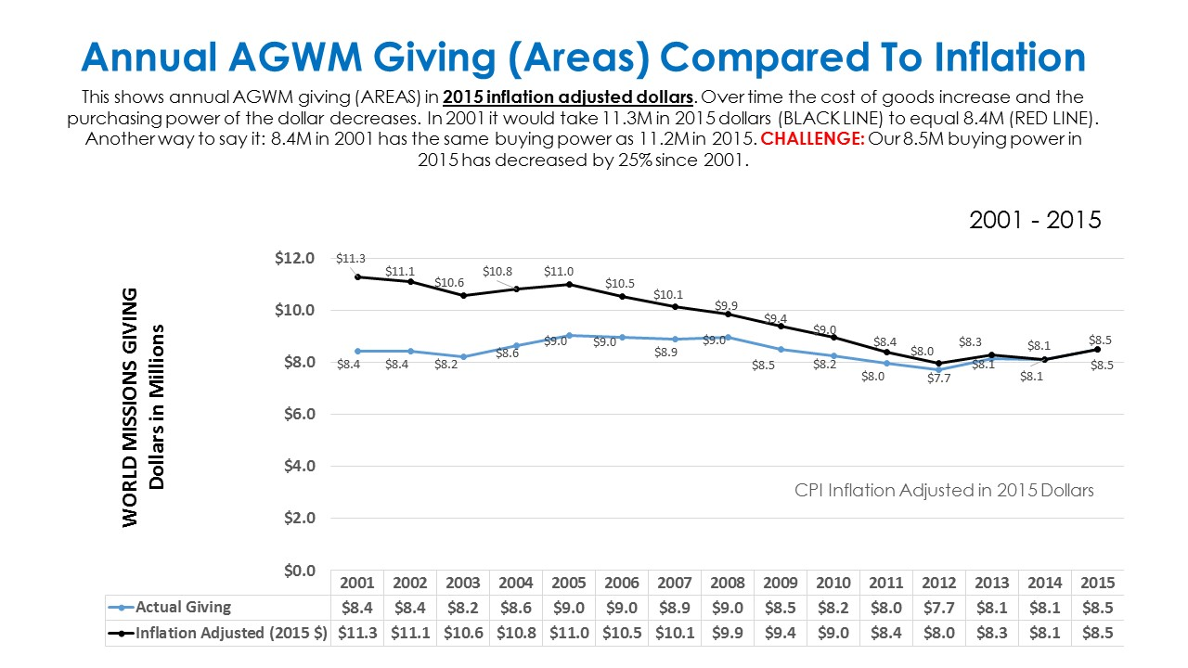

CHALLENGE: Our 8.5M buying power in 2015 has decreased by 25% since 2001.

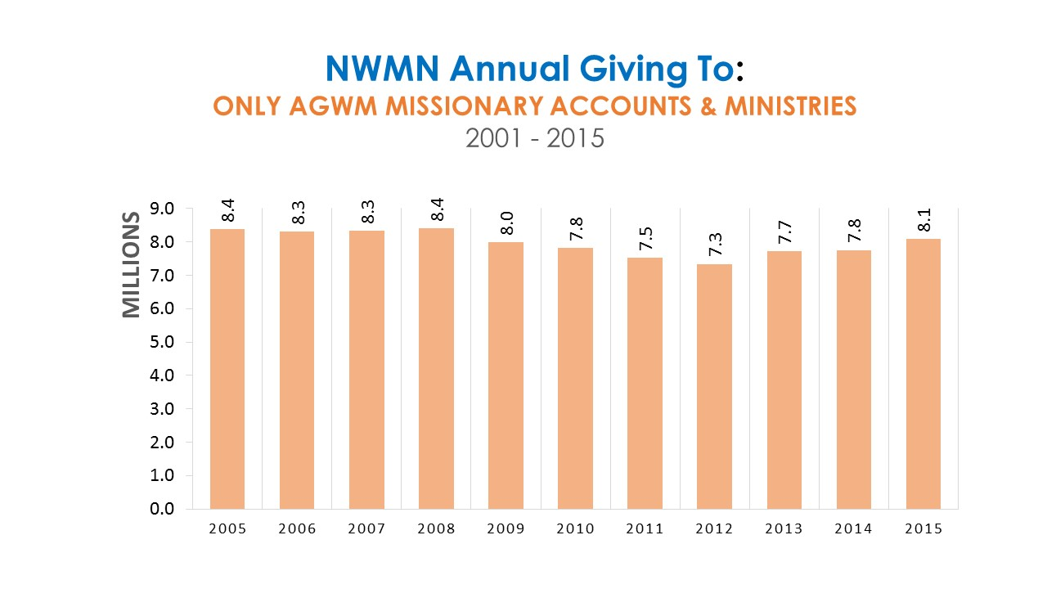

Win: We Rank 8th Among Districts in World Missions Giving

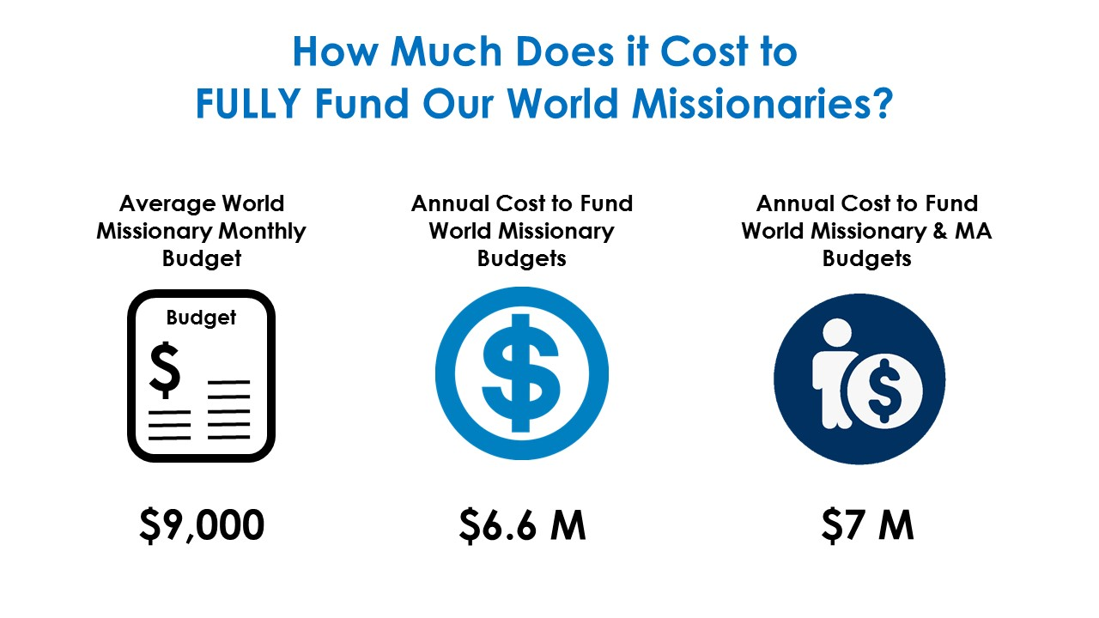

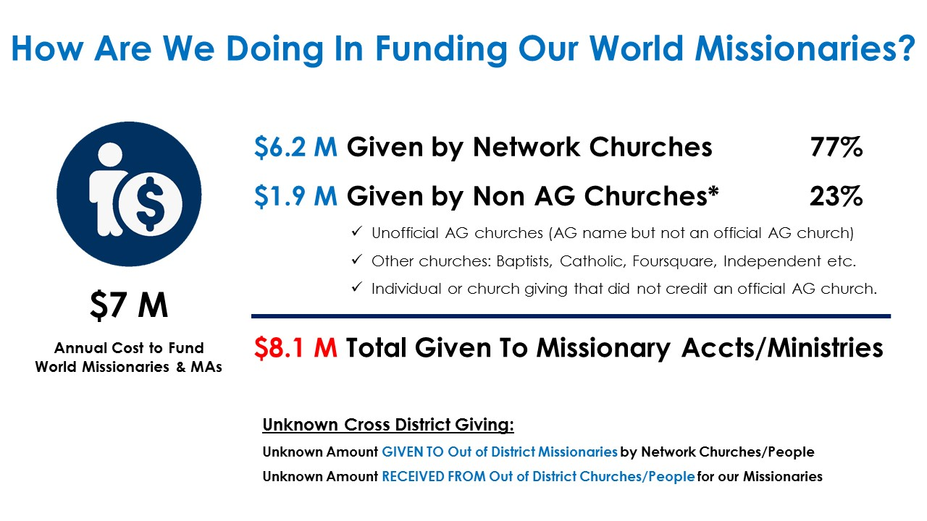

Win: We are bringing in enough and more to support our missionary team.

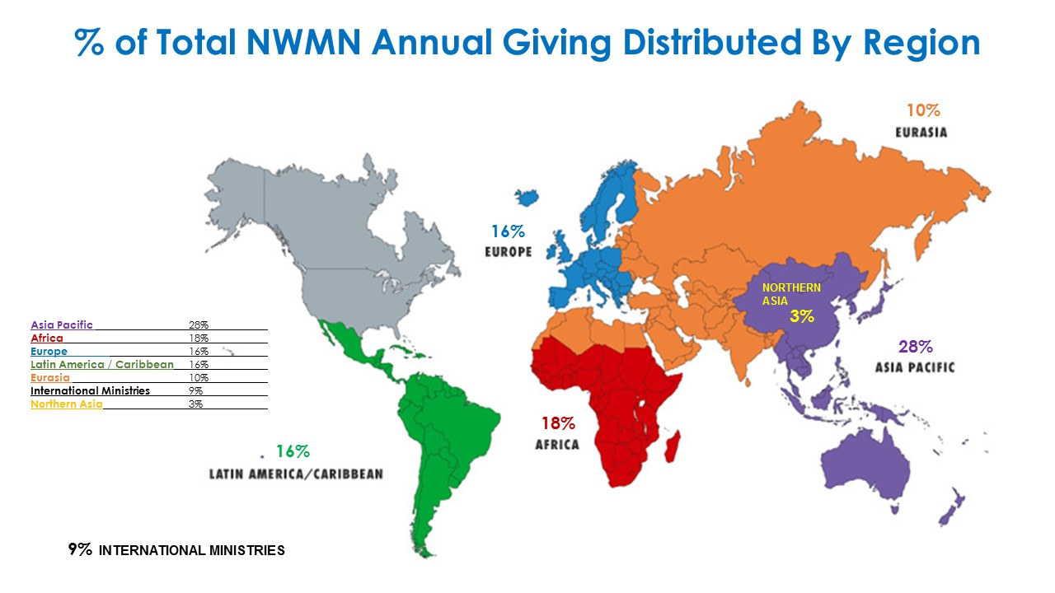

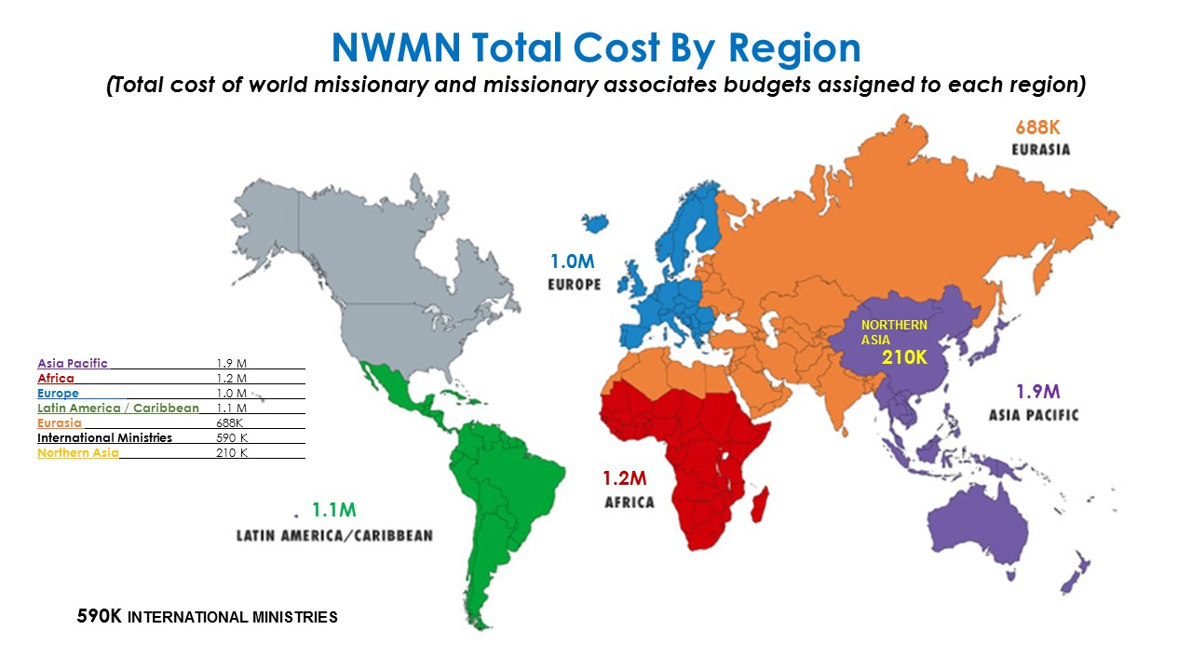

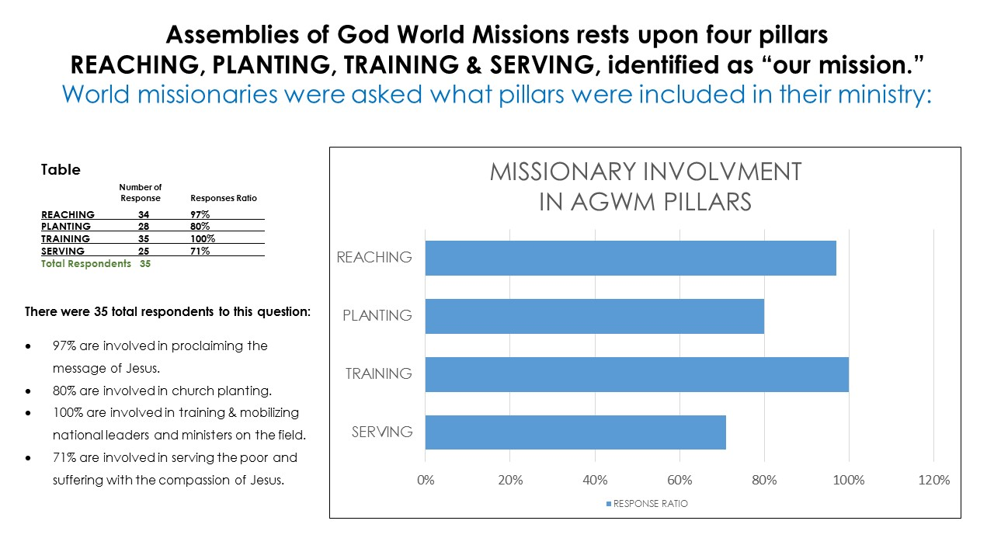

There has been a growing interest in unreached people groups in recent years.

This has been a hot topic as churches wrestle with how to direct missions support. We want to encourage churches to take a both/and approach as apposed to an either/or approach to missions support, which tends to divide the house with serious economic consequences for many missionaries not located among UPGs but they doing indispensable and strategic work around the world.

The key question is not WHERE our missionaries are serving but the KIND of work they are doing.
Does it forward the participation of Christians, churches and missionaries in the global mission? Though we will always pray that God calls more pioneer missionaries to start Christian movements among unreached peoples, it is very important to understand that in many cases one of the most strategic functions a missionary can serve is precisely to work with existing believers, churches and movements to train, mobilize and multiply national workers to carry the gospel into all the world and to the unreached peoples near them.

At the end of the day, the common denominator is a focus on discipling, mobilizing and multiplying ministers to go into all the world to share the hope of Jesus - because THIS is at the very heart and nature of God – The gospel to all peoples everywhere.

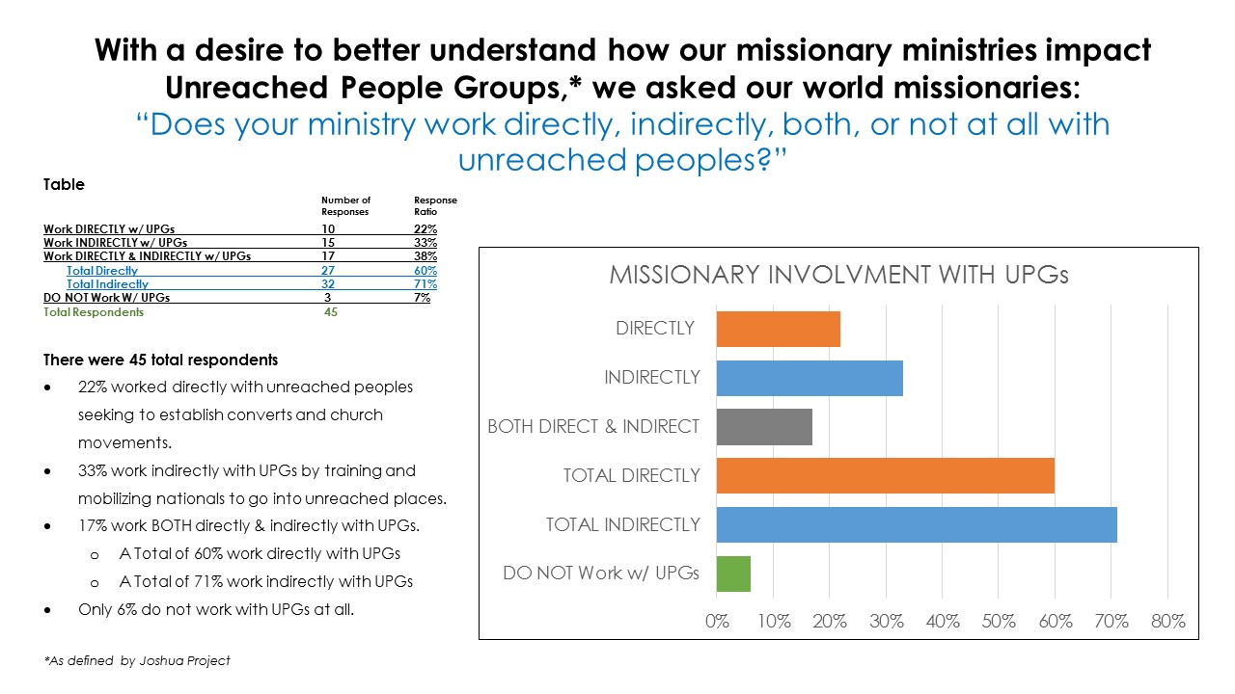

Win: Mobilizing Workers to Reach the Lost & UPGs is Important to Our Missionary Team
The vision to mobilize workers and see the church planted where it does not exist does rests firmly in the hearts of our missionary team.

What Are the Needs & Opportunities Head of Us?

The first leaders and churches who formed the NW District in 1919 had a deep and vibrant missions vision and missionary engagement long before joining the AG. The intensely missions mindedness of those early Network ministers and churches resulted in leading our fellowship for decades with the highest number of missionary appointments, and a waive of strong missions involvement around the world and strong missions support and engagement on the home front. We have ridden that wave for a long time but in recent years, as we have entered a new era, a new culture has emerged with new challenges and new needs which are dramatically felt in the Northwest and among Northwest Network churches. Missions is still at the core of our Network but we have seen a slow down from that early missions thrust. As times are changing, we are becoming farther removed from those early years of missionary fervor and we need meet the new needs for a new day and to continue to cast a strong missions vision and cultivate a deep missions mindedness among Network pastors and leaders. This is going to be a group effort.

Missions System Health

It’s important to understand that we are apart of a missions support system that involves: AGWM, the Network, missionaries and churches. And each has their unique needs, challenges, and opportunities to grow. And each has a vital role to play in the system. So, the question is, HOW do we maintain a strong missions system that will continue our legacy for decades to come? What do we need to be doing? What approaches should we be taking? What priorities should we be investing in?

If we are to maintain a strong missions orientation we must anticipate the emerging needs in our support system and find innovative ways to meet those needs. We have identified 5 key areas in our missions support system that are vital to the health of the system. These areas are ongoing needs for every party in the system and they integrate with one other - meaning, the health of one part affects the health of another part. When all parts are strong the health of the whole system is strong (and visa versa).

Over the years, in trying to express some of the pressures pastors feel regarding missions support, we have heard some say the “system is broken.” And when pressed on what they mean, their angst tends to boil down to some common tension points that correspond with the 5 key areas we identified:

- HEALTHY PARADIGM: Some have a perception that AGWM does not relevantly connect to a younger generation or that perhaps many of our missionaries are not engaged effective gospel ministry. We feel this is not true but at the end of the day perception is reality.

- HEALHTY BRAND: Pastors don’t want another poor missionary presentation (clean up on aisle 4. Every sub par presentation hurts the pastor’s ability to promote AGWM missions effectively in and missions confidence goes down.

- HEALHTY RELATIONSHIP: At times pastors have expressed that missionaries don’t understand the needs and challenges that they face (and missionaries would say the same.) “If they only knew how limited my time is and that I have more missionary & giving requests than I know what to do with.

- HEALHTY PARTNERSHIP: We want to partner with missionaries who we feel are engaging in life transforming gospel ministry and changing lives for the kingdom of God.

- HEALTHY GIVING: Pastors have expressed they would love to give more to missions but their budget is maxed and they greatly dislike having to say “no” to missionaries – many avoid missionaries all together rather than honestly telling them and blessing them with encouragement and prayer.

Does this point to a “broken system”? No. We don’t believe the system is broken, but we do believe there is legitimacy to these 5 areas of need in our support system. However, we feel there has been unhealthy or miss guided expression of these needs on the part of some pastors and missionaries a like. The Network has recognized these needs for some time and has started a number of initiatives to help.
THE OPPORTUNITY AHEAD:
Together We Can Cultivate Each of the 5 Areas:

