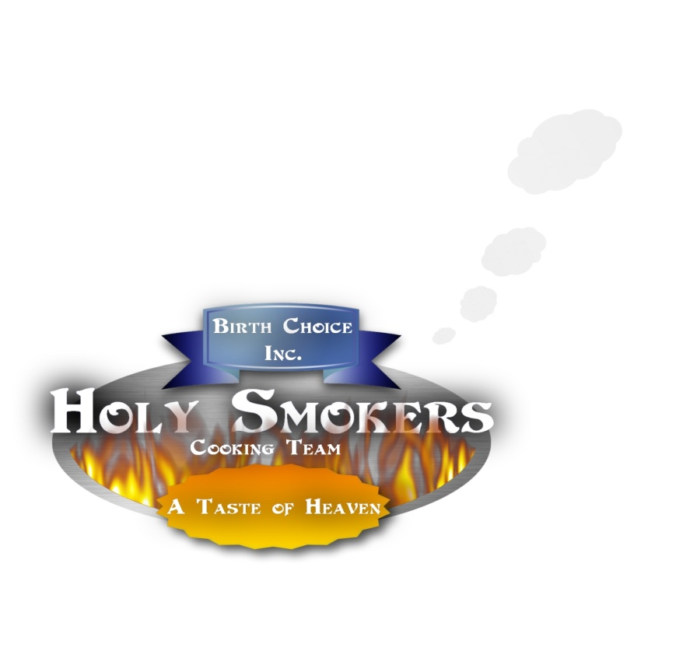

BIRTH CHOICE
THANKSGIVING MEAT SALE
on WEDNESDAY NOVEMBER 25TH
PICKUP LOCATION is BIRTH CHOICE of JACKSON from 8 AM-NOON and GIBSON COUNTY 9 AM- 11AM

NAME | PHONE # | EMAIL | # OF  FRIED  TURKEYS | # OF SMOKED TURKEYS | # OF HAMS | # OF TENDER-LOINS | # OF BOSTON BUTTS | # OF  CHICKENS | LBS. OF  BBQ | SACK LUNCHES | PICKUP LOCATION
*Deadline for Orders is Friday, November 20th @ 2:00 pm. Please contact Cameron @ 664-8443 or cameron@birthchoice.us

