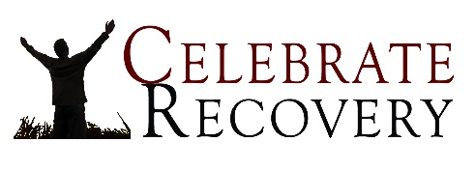
In Search of Freedom – The First Step
Pastor Mike Pratt

Isaiah 57:18 (NIV) “…I will heal them, I will lead them and help them and I will comfort those who mourn. I offer peace to all near and far.”
Because of sin, we all need recovery. 100% of the human race needs recovery. What do we need to recover from? Here are just a few things from which we need recovery:
Overworking | Overeating | Alcohol/Drugs Overspending
Grief | Guilt | Anger/Rage
Fear/Anxiety | Divorce | Abuse
Sexual addictions | Codependency | Insecurity
Perfectionism | Hypochondria | Hurtful relationships
Gambling | Lying | Procrastination
 | The need to control

There are steps to recovery. The first step to R E C O V E R Y is:
Realize I’m ______________________; I admit I’m powerless to control my tendency to do the wrong thing and my life is unmanageable.
Romans 7:15–17 (NIV) ¹⁵I do not understand what I do. For what I want to do I do not do, but what I hate I do. ¹⁶And if I do what I do not want to do, I agree that the law is good. ¹⁷As it is, it is no longer I myself who do it, but it is sin living in me.
- THE CAUSE OF MY PROBLEM: ________________________
How we “play” God:
By denying our ________________ and by trying to ________________ everything for selfish reasons.

• Our image
• Other people
• Our problems
• Our pain

- THE CONSEQUENCES.
  - _____________________
(Adam) “I was afraid because I was naked so I hid.”
Genesis 3:10
  - _____________________
“It seems to be a fact of life that when I want to do what is right, I inevitably do what is wrong … something else deep within me … is at war with my mind and wins the fight and makes me slave to the sin …” Rom. 7:21, 23
“My dishonesty made me miserable and filled my days with frustration.” Psalm 32:3
  - _____________________
“My strength evaporated like water on a sunny day until I finally admitted all my sins to you and stopped trying to hide them.” Psalm 32:4–5
  - _____________________
“You will never succeed in life if you try to hide your sins. Confess them and give them up; then God will show mercy to you.” Proverbs 28:13
- THE CURE: ____________________________________________
Admitting that I’m not God means I know I am:
powerless to change:
powerless to control:
powerless to cope:
“God opposes the proud but gives GRACE to the humble.” James 4:6
GRACE IS:

