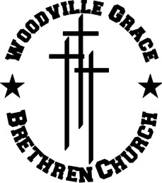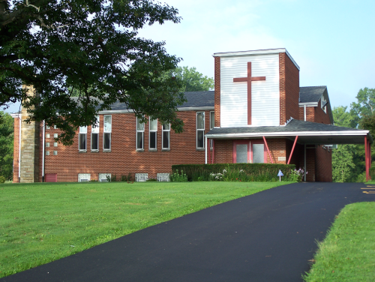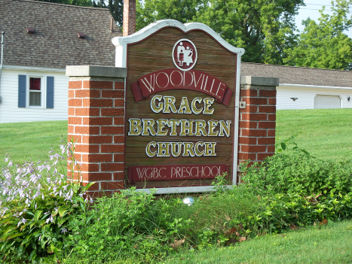WOODVILLE GBC

• Its mission is to make disciples who love God and love people

• Striving to help people in a 1 mile radius around the church building

• Not just doing church but being the church by doing good works

• Helping the community through-

- street clean-up projects

- counseling

- providing activities to keep children and teens off the streets,

i.e. AWANA, youth group, Kids Zone

- teaching good morals and supplying healthy role models

- feeding the poor

- offering classes to help improve lives

- yearly Block Party featuring a bounce house, cotton candy, games, etc.

- preschool that gives a solid foundation in morals, ethics, and the 4 R’s

- wood working ministry