FOOD PANTRY
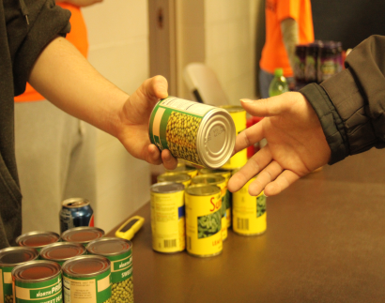
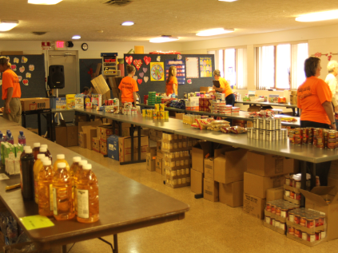
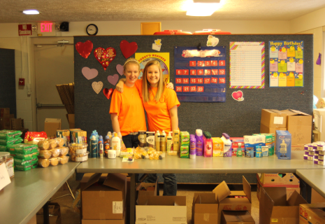

• Meeting needs both physically and spiritually
• Purchase food from Cleveland Food Bank to feed people who qualify
• Targeting families within a 1 mile radius of the church building
• Average 150 families per month (500 individuals)
• People shop at the choice pantry picking the foods that they like
• Providing three meals per person in the household per day for three days each month
• 61% of the people in the 1 mile radius qualify

• Distributed approximately 50,000 meals in 2013

