Grace Brethren Church members doubling down on food pantry

6:35 AM, Oct 18, 2012 |

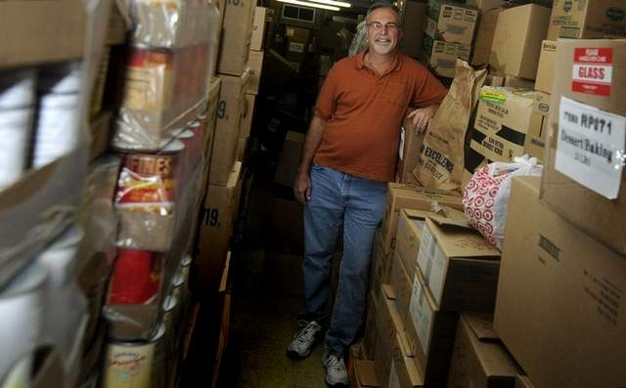

The Rev. Ron Smals in the food pantry of the Woodville Grace Brethren Church. / DANIEL MELOGRANA/NEWS JOURNAL

Written by

Lou Whitmire

News Journal
MANSFIELD -- The Rev. Ron Smals' parishioners at Woodville Grace Brethren Church are helping to put food on the table for 150 families in the neighborhood each month.
Now they want to do more.
The 580 Woodville Road church has operated a food pantry for more than two years. It is open the fourth Saturday of each month. People who qualify arrive about 9 a.m. for the free food and the pantry remains open until the food is gone.
Smals said individuals must bring ID and a recent utility bill, as the church food pantry serves families or individuals within a one-mile radius of the church south of Cook Road and down Woodville to Illinois Avenue and Park Avenue East to Main Street.
"When we started we had 75 to 80 families. For every person in the household we provide three meals for three days," he said. "In 2011 our program purchased 103,664 pounds of food. I know that number has increased."
Smals said those people coming to the food pantry are able to choose some of the items they need, depending on the size of their family.
"We carry the food to their cars," he said.
The church of about 200 parishioners buys food from the Cleveland Food Bank, and the church receives deliveries twice a month.
Smals said the church is hoping for a $500,000 miracle.
Members want to build a new structure at the rear of the church to primarily house the food pantry. Currently, refrigerators and freezers are located throughout the church.
The church rents a pod for $310 a month to store canned goods and other non-perishable items and everything from diapers to coffee.
"The plans are drawn," he said, noting the building would include restrooms and more.
Smals said the community is generous and members and non members also donate to the food pantry. ‘We recently received a $2,000 donation from the MedCentral Civic Fund," he said.
Seventy members of the church volunteer to help operate the food pantry. Smals said many of the neighborhood residents need help.
"We're meeting the needs both spiritually and physically," he said. "We have such a heart for this one-mile radius."
Smals said there is a basketball ministry for youth, a preschool and other programs for youngsters.
"We have a heart for the hurting people," he said. "We don't want to do church. We want to be church. The church is supposed to be making the community a better place to live."
With seven years at Woodville Grace Brethren, Smals said he gets a lot of help from the administrative staff at his church.
"I've had more fun than I've had in my 31 years of ministry," he said.
The friendly pastor said anyone who wants to help donate to the food pantry or volunteer is welcome to call him at 419-524-8552.
lwhitmire@nncogannett.com
419-521-7223
Twitter: @Lwhitmir

