GRACE YOUTH MINISTRIES
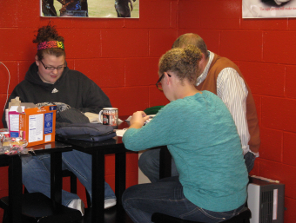
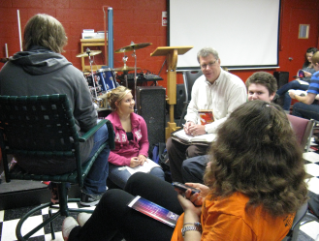

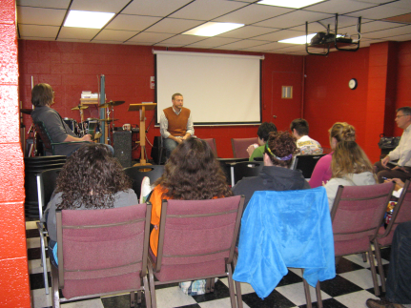
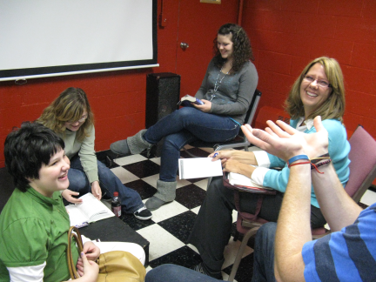

Woodville Grace Brethren church is centered in a diverse community. We understand that it is hard on families in today’s times to raise kids, work and contribute to society. Therefore we are committed to:
- Training young people to be responsible
- Creating a healthy understanding of who they are
- Inspiring and encouraging them to rise above the hard times
- Providing a fun and welcoming place to grow

