WGBC PRESCHOOL
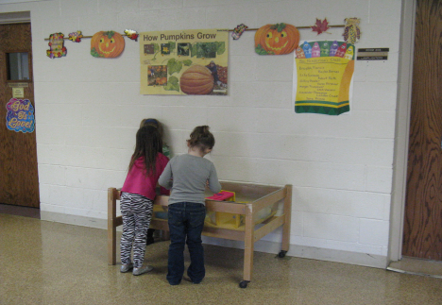
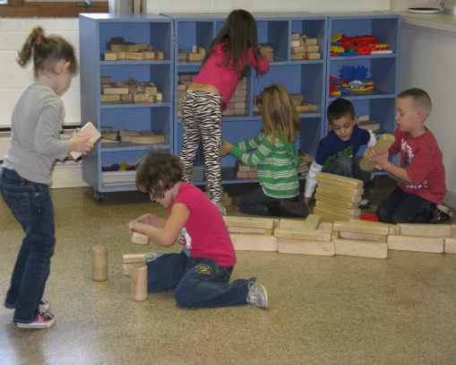
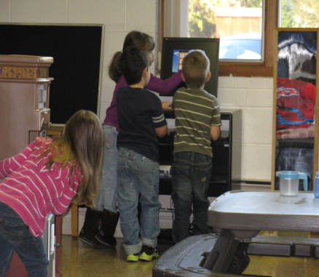

- Providing children and families of our community a well rounded preschool program that offers activities presented in a fun, age appropriate manner with a hands-on approach to learning
- Bible Teaching and Scripture memorization as well as academics
- Teaching through music, art and movement
- Children develop early childhood skills in the areas of :
-socialization
-thinking
-language
-reading readiness
-pre-math
- Taught by a loving, caring staff in a safe environment
- Healthy role models

