COMMUNITY ALTERNATIVE CENTER
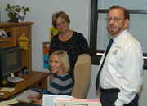

- Men’s Team & Women’s Team from our church meet every Monday at the Center
- Men & Women are offered Bible Classes for one hour
- Only Eternity will tell how many are set free from drug addiction
- The Bible says, “If the Son shall set you free you will be free indeed”
- No one knows how many have prayed to receive Christ
- God has given this open door to an amazing ministry

