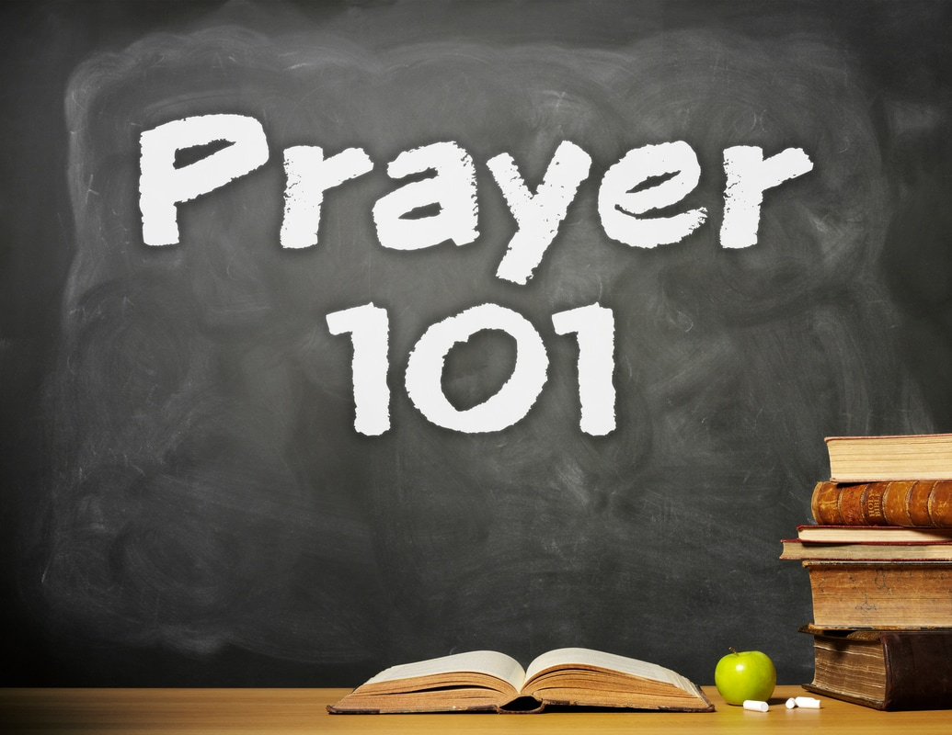
Prayer 101:
Forgive Me!
Matthew 6:12
Pastor Wade Smith
Oswego Alliance Church
October 14, 2018

Defining Forgiveness
- The word that is used in the Lord’s Prayer (Aphiemi) is used to describe the releasing a person or thing that we control. It means to set free. It means to be released from punishment for some wrongdoing.

Defining Sin
- Five words used in the New Testament for sin.
  - Romans 3:23; Luke 15:21 – This particular word is used several times in the New Testament and carries the meaning of “Missing the mark.”
  - Eph. 2:1; Col. 3:13 – This word is often translated “offenses” or “trespass” in the New Testament. It carries the idea of “slipping or falling.”
  - James 2:9 – This word is usually translated as “transgression.” It refers to “an intentional crossing of the boundaries established by God in His Word.”
  - 1 John 3:4; Matt. 7:23 – This word is usually translated either by “iniquity” or by “transgression.” It literally means “without the Law or lawlessness.”
  - Matt. 6:12 – This words is translated “debt, debtor or ought.” It refers to something that is “owed to another party.”

Defining Conditions Of Forgiveness
- “I am never more like Jesus than when I can forgive those who have offended me! So, when I pray this simple prayer, I am saying, ‘Lord, help me to be more like you!’” (Alan Carr)

