welcome visitors
We are glad that you have decided to join us in our worship service today. Please let us know how we can best serve you and your family.

Immediately following the service, the pastors and elders are available at the front of the sanctuary to
pray with you for any needs and concerns.
week at a glance

Sunday: Kids Life Groups* 10:00 AM
Worship Service 10:00 AM
Awana 5:00 PM
Youth CLG 5:00 PM
Monday: Men’s Bowling 6:00 PM
Wednesday: Worship Practice 6:30 PM
Deacons Meeting 7:00 PM
Thursday: Ladies Bible Study 9:15 AM
Bom Meeting 7:00 PM
Friday: Quilters 1:00 PM
Saturday: Quilters 9:30 AM
Next Sunday: Kids Life Groups* 10:00 AM
Worship Service 10:00 AM
Awana 5:00 PM
Youth CLG 5:00 PM
* Children will be dismissed during the Worship Service
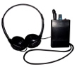
Hearing Impaired: We have headsets available at the Sound Booth.

Download the Bible App: on your smart phone or tablet to
follow along with the sermon today. Visit

Bible.com/app. Search for events [Oswego

zip code 13126 if needed]. Join on our free wifi
His Community Reaching our Community

Hot Spot. It allows one hour per device.
His Community Reaching our Community

adult ministries
Thursday: Ladies Bible Study: Thursdays, 9:15-11:30AM
Community Life Groups: See back of bulletin
youth ministries

Friday: Youth Group at CC, 7PM
Sunday: CLG 5-6:30PM at Cheeleys (153 Tallman St)
children’s ministries

Sunday: Nursery for birth through age 2
Kids Life Groups dismissed during the
service for 2 yrs-6th Grade
AWANA: 5PM at the Community Center
Tuesday: Oswego Moms Group meets at Community
Center from 10AM-12PM twice a month.
Contact Val Yawger @ yawger2@gmail.com
for more information.
nursery caregivers

Today:
Infants: Becky Manwaring & Crystal Cavellier
Next Sunday:
Infants: Susan Wild & Cailee Dawson

financial information
General Fund: Giving Last Week $....8,197
Weekly Budget………………...$....8,885
Year to Date Giving $..96,942
Budget Need $115,505
Expenses Paid $104,769
Missions: Giving Last Week $....1,085
Weekly Pledge $.......891
Year to Date Giving $..10,331
Pledge Need $. 10,692
.
hospitality ministry

April 7&14 Ushers/Greeters: Carol Holliday
library volunteers

April: Brenda Wells
birthdays

Birthdays: Megan Cheeley, 4/7; Myron Jones, 4/7; Addison LaRue, 4/7; Cheryl Lautensack, 4/9; Parker Maynes, 4/9; Madison Melita, 4/9; Titus Kropf, 4/10; Brandon Cheeley, 4/11; Jeanne Crouse, 4/11; Janet Erskine, 4/12; Musteriya Baldwin, 4/13; Alexander McRae, 4/13; Greg Mills, 4/13; Seth Pagliaroli, 4/13

church life information
Monthly Usher/Greeter meeting next Sunday, April 14, right after the service, in classroom A. See you there.
MENS BOWLING – Monday, April 8, 6PM at Lighthouse Lanes (behind the east side McDonalds). $1 per game and $1 shoe rental. Come out and have some fun.
LADIES: - We hope to see you next Saturday, April 13th, from 9-11 for some Coffee & Conversation! We meet in the cafe area of the church. Feel free to come for a few minutes or stay the whole time! **child care is provided**
CHURCH MEMBERSHIP: If you are interested in church membership, please contact Barney Johnson, Membership Elder, at 315-342-9297 or mrbjohnson29@gmail.com.
GOOD FRIDAY SERVICE: Friday, April 19, 7PM at the Oswego Alliance Church. Join us as we commemorate Good Friday with the other Evangelical churches in the area.
PALM SUNDAY: Both Pastor Verlyn and Pastor Wade will be away on Palm Sunday, so Pastor Dick Beaumont will be preaching that day.
MEN’S RETREAT AT DELTA LAKE: Friday, May 3rd & Saturday, May 4th. For more details, see the flyer on the bulletin board.
youth ministry news

CHURCH FAMILY: if you have odd jobs teens who are going to LIFE 2019, speak with Danny Oostdyk or Amy McDougall and they will seek to get you connected.
SAVE THE DATE: YOUTH DINNER & SERVICE AUCTION: Saturday, April 27, 4-6 PM at the Community Center. See the insert for more details.
children’s ministry news

VOLUNTEERS NEEDED: Volunteers are needed for our Children’s Ministry. If you can help out, please sign up at the information table in the narthex. Thank you.
AWANA: 5PM, Regular Club Night

community life groups
LaRue – Sunday 12pm
Steve & Katie Pagliaroli’s home (162 E 7th St)
Study – Letters to the Church
Lautensack – Sunday 12-1:30pm
Orange Room at the church
Study – The Christian Life
Baldwin – Sunday 2-4pm
Lowell & Cindy Porter’s home (12731 Maurer Rd, Cato)
Study – Grace
Breese – Sunday 2-4pm
Cindy and Tom Brooks’ home (322 Thompson Rd, H-9)
Study – James
Smith - Sunday 5-7pm
Wade & Wendy Smith’s home (274 Syracuse Ave)
Study - Mark
Jones – Tuesday, 7pm
Art & Jodi Jones’ home (2094 Co Rt 8)
Study – Colossians by Louie Giglio
Creation Studio - Monday 8:15pm
Creation Studio (157 E 1st St #6)
Study – 2nd Corinthians
Pierce - Tuesday 6:45pm Tuesday 6:45pm
St. Luke’s in the Adult Day Care Room on the first floor
Johnson - Tuesday 7-9pm
Fred & Cindy Orr's home (5587 St Rt 104)
Study – Mark
Ratzlaff (Men’s CLG) - Wednesday 8am
Orange Room at the Church
Study – Judges
Seniors CLG– 2nd & 4th Wednesday, 1pm
Library at the Church
Study – New Testament Prayers
Galka (Prayer CLG) – 1st & 3rd Wednesday, 7pm
Classroom A at the Church
Theme – Stepping Out
Bouffard (Single Women’s CLG) – Wednesday 6:30pm
Terri Bouffard’s home (1738 Co Rt 7)
Study - Fruit of the Spirit
Altman/Ratzlaff (Women’s CLG) Thursday, 6:30-8pm
Altman’s home (2938 St Rt 48, Minetto)
Study – Redeeming Revelation: Our Response to God’s Love
OAC Women’s Ministry - Coffee & Conversation
3rd Saturday of every month 9-11am
Café area at the Church
For more info, please contact Pastor Verlyn at pastorverlyn@oswegoalliance.org
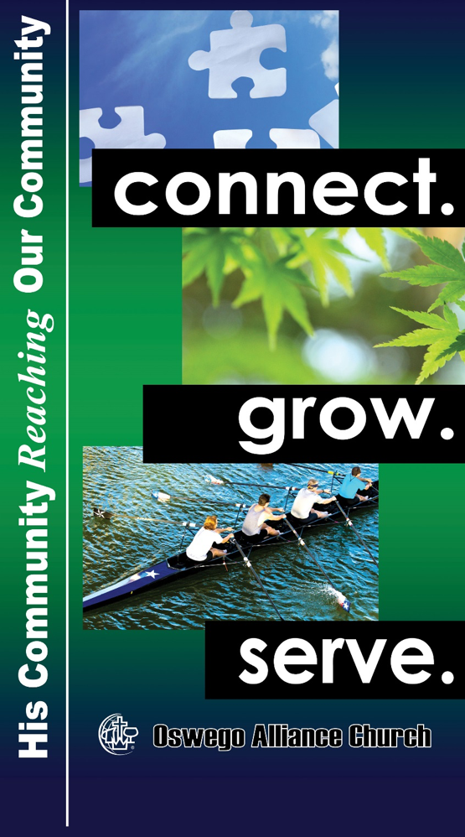

April 7, 2019
, 2018
,, 2017
,, 2017March 3

371 Thompson Road • Oswego, NY 13126 • 315.342.5493
Community Center • 370 Thompson Road • 315.342.5315
E-mail: info@oswegoalliance.org • www.oswegoalliance.org
Wade Smith, Pastor • pastorwade@oswegoalliance.org
Verlyn Ratzlaff, Pastor • pastorverlyn@oswegoalliance.org
Carla Ratzlaff, Worship Director • cratzlaff@oswegoalliance.org
Danny Oostdyk, Youth Director • ocmayouth@gmail.com

