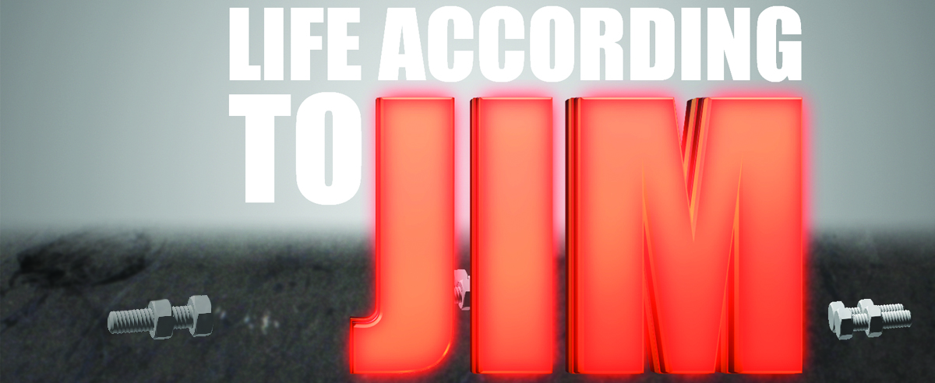

Week 2 “When Trials turn to Temptations”
James 1:9-11
There are two perspectives of riches here.
- Riches are ________________________.

- Riches are ________________________.
James 1:12
- God’s _________________________. When we persevere - go through trials God’s way - God blesses us.

- God’s approval ___________________________
- Crown of ________________________________
James 1:13-15
Seek God and Live __________________
Bottom line: In trials when we’re not seeking after God, His wisdom and His way through the trial we’re in a process of self-destructive behavior.
James 1:16
“Do not be deceived.” We have a __________________!!!

Week 2 “When Trials turn to Temptations”
James 1:9-11
There are two perspectives of riches here.
- Riches are ________________________.

- Riches are ________________________.
James 1:12
- God’s _________________________. When we persevere - go through trials God’s way - God blesses us.

- God’s approval ___________________________
- Crown of ________________________________
James 1:13-15
Seek God and Live __________________
Bottom line: In trials when we’re not seeking after God, His wisdom and His way through the trial we’re in a process of self-destructive behavior.
James 1:16
“Do not be deceived.” We have a __________________!!!

