General Information
Name: |  | Date: / /
Address: | Home Phone:
 | Business Phone:
 | Mobile Phone:
 | Email:
Birthdate (for background check):

Driver’s license number: | Other Names Used in the Past:
Interest in (check all that apply):  - Classroom assistance (teacher prep, working with struggling students)  - Coaching (teach in PE, lead an extracurricular team)  - Office/Administrative (front desk) | - Special Events (baking desserts, providing decorations, taking photos)  - Teaching (teach an elective, leading a seminar)  - Other: _________________________________
What days and times are best for you to volunteer? (E.g., MWF, 8-11am)
(Please note: classroom tutors should be prepared to commit to one class period/week.)

References
Please list information for a character reference we can contact who is not a member of your immediate family:

Name:
Phone:
Email:
Relationship:

Please list information for a professional reference (or someone who has worked with you in a volunteer capacity) that is not a member of your immediate family:

Name:
Phone:
Email:
Relationship:

Questions
- Why would you like to volunteer at Eastside Academy?

- In what capacity do you see yourself volunteering at EA?

- Describe your Christian experience/faith journey.

- Please describe your ability to work effectively with at-risk youth, especially those who struggle with addiction.

- Briefly describe your current professional situation.

- Please list any current certifications you hold, as well as any special talents or hobbies you have.

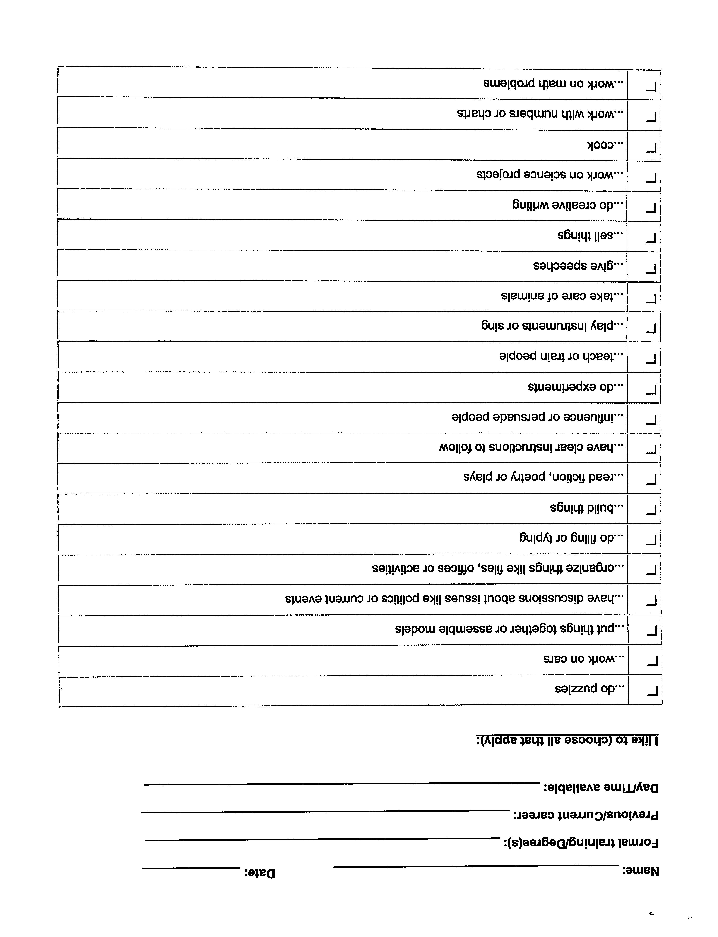

What We Believe
The Word of God We believe that the Bible is the Word of God, fully inspired and without error in the original manuscripts, written under the inspiration of the Holy Spirit, and that it has supreme authority in faith and conduct.
The Trinity We believe that there is one living and true God, eternally existing in the three persons, that these are equal in every divine perfection, and that they execute distinct but harmonious offices in the work of creation, providence and redemption.
God the Father We believe in God, the Father, an infinite, personal spirit, perfect in holiness, wisdom, power and love. We believe that He concerns Himself mercifully in the affairs of humans, that He hears and answers prayer, and that He saves from sin and death all who come to Him through Jesus Christ.
Jesus Christ We believe in Jesus Christ, God's only begotten Son, conceived by the Holy Spirit. We believe in His virgin birth, sinless life, miracles and teachings. We believe in His substitutionary atoning death, bodily resurrection, ascension into heaven, perpetual intercession for His people, and personal visible return to earth.
The Holy Spirit We believe in the Holy Spirit who came forth from the Father and Son to convict the world of sin, righteousness, and judgment, and to regenerate, sanctify and empower all who believe in Jesus Christ. We believe that the Holy Spirit indwells every believer in Christ, and that He is an abiding helper, teacher and guide.
Regeneration We believe that all people are sinners by nature and by choice and are, therefore, under condemnation. We believe that the Holy Spirit regenerates those who repent of their sins and trust in Jesus Christ alone as Savior.

_____ I fully agree with this statement of faith and agree to uphold it in both word and action.

Name:___________________________ Date:_____________

Signature:________________________

