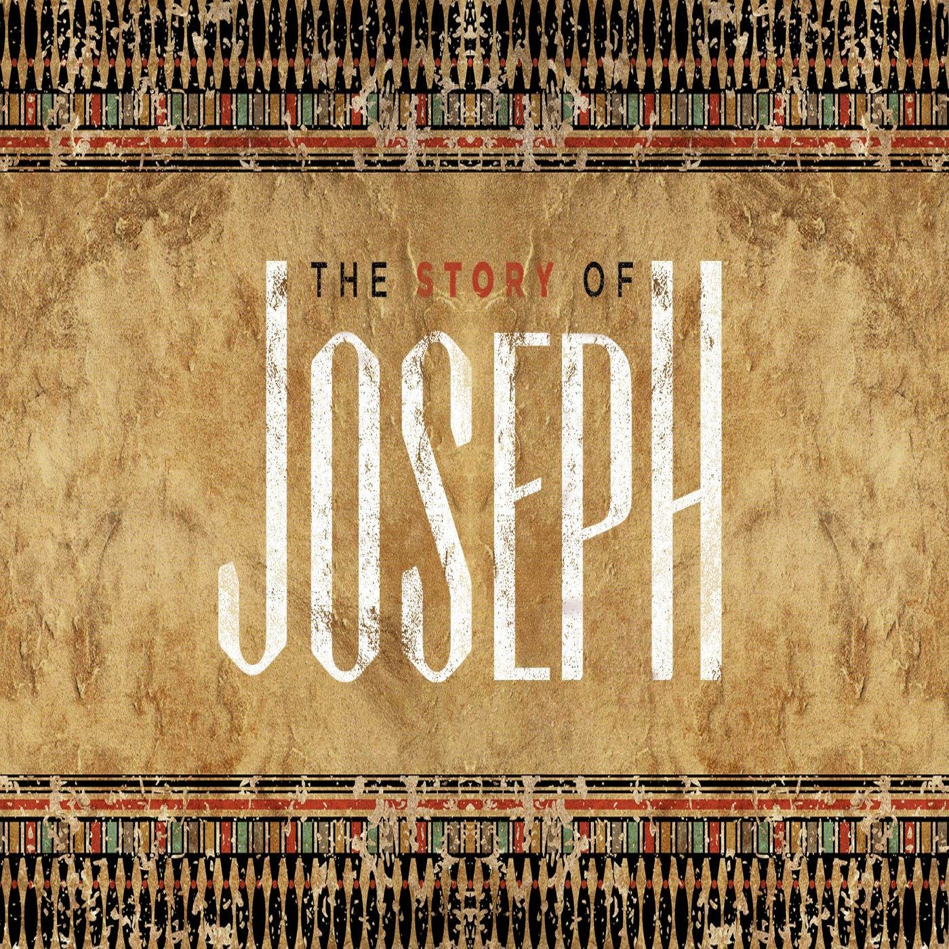

When the Dream Turns to Weeping
Genesis 42
Eric Sorenson October 13th, 2019

Notes to Help You Prepare for Life Group
Take out another sheet of paper, and work through the following questions to help you prepare for your Life Group discussion. This isn’t a test! You don’t need to answer every question; just get the juices flowing.

Identify the key characters in today’s text, and summarize the flow of the story they’re involved in. Pay attention to the character of the persons involved. Is the narrator commending the behavior of certain characters? Who and how?

Jot down the things in the story that confuse you. Are there historical and cultural elements that would be helpful to know? What missing details caught your attention and made you wonder?

Note any repetition of words or themes. What do you think the artist-narrator is trying to get you to pay attention to? Write down what you detect to be the key point of this narrative.

How does God show up in this story? Is God mentioned by name? If not, try to “read between the lines” and see where he might be at work. What does the story indicate about God?

Imagine how this week’s narrative might fit into the story of Abraham. How might it fit into the larger story of the Old Testament? Can you see how this story may connect to the story of Jesus? (For instance, how is Joseph like Jesus?)

Considering what you detect to be the theme in this text, and remembering the other things you’ve noted, what do you think is the “moral” (or “morals”) of the story? What does the story tell you about life, particularly the life of faith? Are there elements from the New Testament that help you apply this?

What is God trying to say to YOU from this week’s text?

