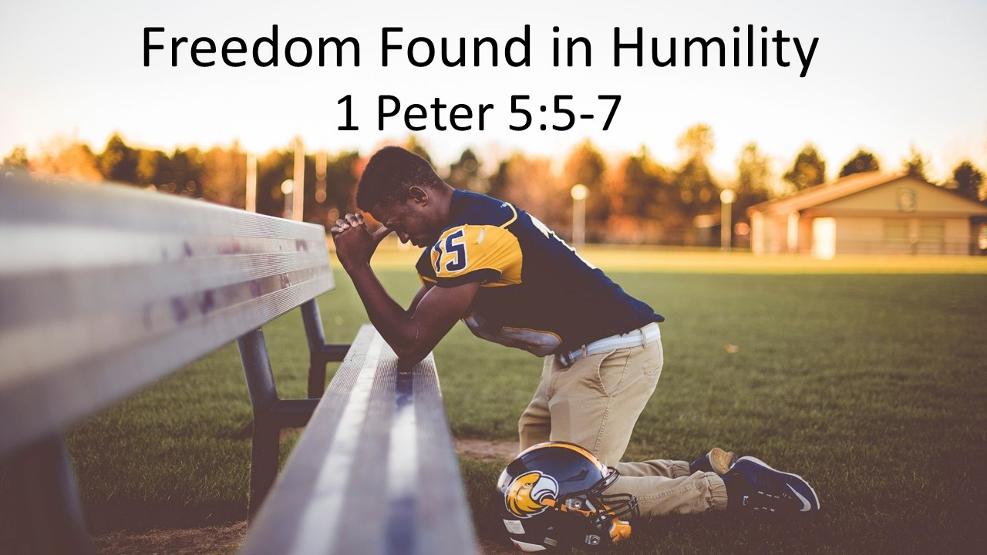
“Freedom Found in Humility”
1 Peter 5:5-7
May 16, 2021

Freedom is found when we humbly rest in God’s sovereign care.

- Be humble before EACH OTHER (5a)

- Be humble before God (5b-7)

    - By RECOGNIZING who He is (5b)

    - By TRUSTING in His will & timing (6)

    - By HANDING OVER your worries to His care (7)

