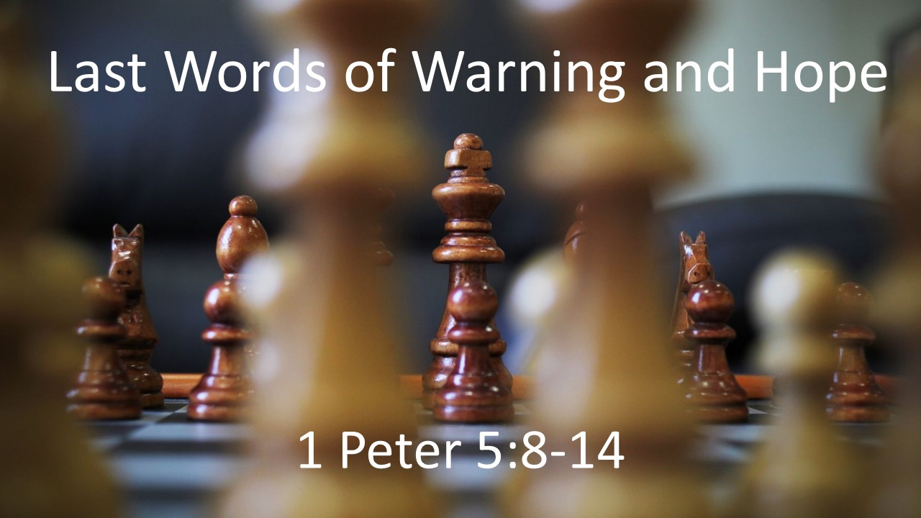
“Last Words of Warning & Hope”
1 Peter 5:8-14
May 23, 2021

In the midst of suffering, know who you are against, who is with you,
and who will bring you through.

- Be ALERT - Your dangerous enemy is on the prowl. (8-9)

- Be ENCOURAGED – You don’t stand or suffer alone. (9,12-14)

    - Hold your part of the LINE.

    - Remember and pray for those who have it WORSE.

    - Have the courage to SHARE your suffering with others.

- Be HOPEFUL – Your great God of grace will see you through (10-11)

    - Put the trial in PERSPECTIVE.

    - Remember who GOD is.

    - REFOCUS on His ultimate calling and purpose for you.

    - Rest in His PROMISES.

