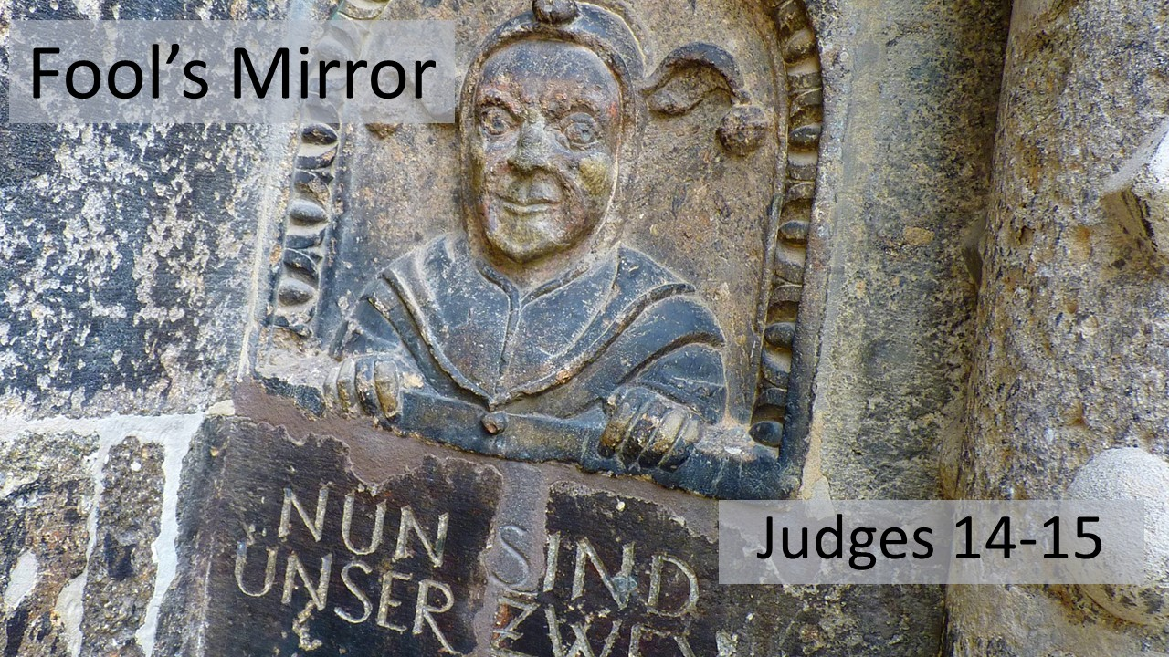
“Fool’s Mirror”
Judges 14-15
September 19, 2021

God can use even a fool as an instrument in His gracious plan.

- Fools have their mind made up by their DESIRES, not by any other authority.
(14:1-4)

- Fools believe they are the exception to every rule, not SUBJECT to God’s commands. (14:5-9)

- Fools are wise in their own eyes, not seeing their own WEAKNESS. (14:10-20)

- Fools repeat their folly, not LEARNING from their mistakes. (15:1-8)

- Fools are motivated by revenge and retaliation, not remembering their own FAULTS. (15:9-15)

- Fools put the SPOTLIGHT on themselves, not seeing God’s grace in their lives. (15:16-20)

