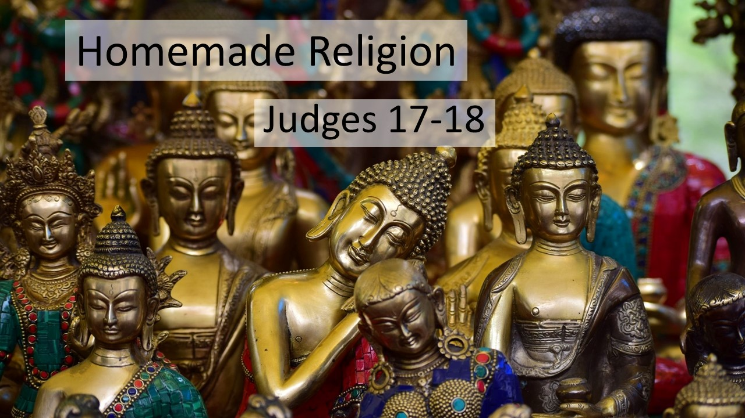
“Homemade Religion”
Judges 17–18
October 17, 2021

Self-made, customizable, and convenient religion will never give us what we need,
only worshipping the true King will.

We have rejected God as king when…

- We redefine God according to what we think is RIGHT while ignoring His Word. (17:1-6)

- We seek to use and CONTROL God instead of surrendering to Him in worship. (17:7-13)

III. We go looking outside what God has provided for the REST we can only find in Him. (18:1-13)

IV. We outwardly “win” while LOSING any sense of what we are called to do and be. (18:14-31)

