Lindsay Diederichs [mailto:ldiederichs1987=gmail.com@mail90.atl111.rsgsv.net] On Behalf Of Lindsay Diederichs
Sent: Monday, July 27, 2015 9:18 AM
To: Weller, Jeffrey P
Subject: If you don't quit, you win!

PLEASE NOTE: A CHANGE TO THE DONATION PROCESS
Details at the end of the email.
View this email in your browser

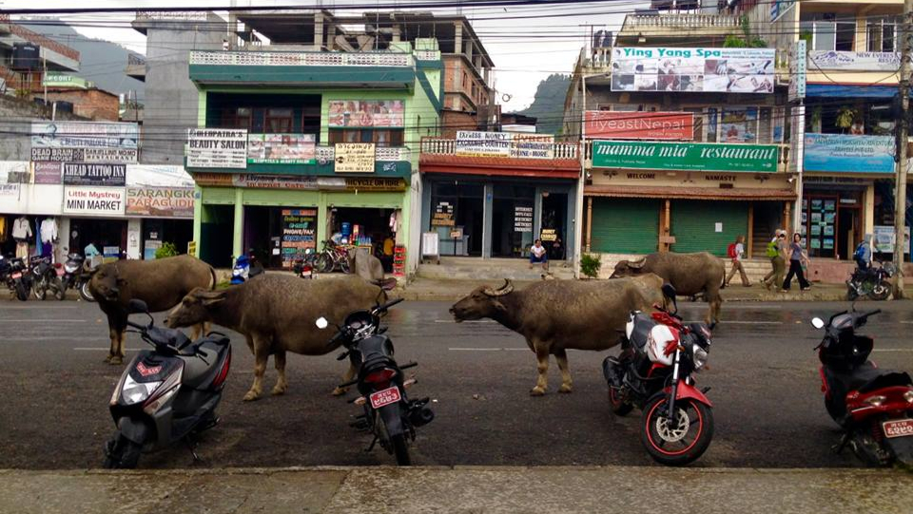

If you don't quit, you win!
I have been clinging to the truth "If you don't quit, you win" as I have faced different challenges this last month. It was harder than ever to say goodbye to my family - my sister is pregnant with her second child (whose arrival into this world I will miss) and my nephew is cuter than ever! I was very grateful for the comfort of family and the conveniences of the West and so it is taking a new bout of stamina to endure the humidity, snakes, insects and stomach bugs of monsoon season.

I was also having trouble receiving my long-term visa to stay in Nepal. My second research proposal finally got approved by the University, but the paper work kept getting delayed. Lastly, one of my closest 'heart friends' will be leaving Nepal next month indefinitely and Matt and Shonnie are away on their honeymoon till September.

I was struggling to find motivation and prayed that the Lord would renew my vision and purpose. Then a few days later while spending time with 'my girls' (the three I have been discipling since my arrival) they told me that if it weren't for me they would have left the guesthouse. They called me the 'blessing person' and thanked me for how much I have taught them and for truly caring for them. It was such a gift to be reminded that I am having a significant impact in their lives!

There are various constraints that prevent me from being as 'productive' as I would like. Some are cultural and governmental, others are health-related. In the ensuing moments of frustration, I lean into the promise that I am the 'temple of God' and that Holy Spirit dwells inside me. Therefore when I can do nothing else, just the simple act of residing in this country, worshiping Jesus daily, interceding for my neighborhood and talking to my Nepali friends about Jesus is producing change. Of course the enemy would want me to give up, but I know in my heart "if I don't quit, I win".

If they had longed for the country they came from they could have gone back.
But they were longing for a HEAVENLY HOMELAND.
- Hebrews 11:15-16

Pray this longing in my heart would be stronger than any other and that I would find my heavenly homeland here in Nepal in the comfort of God's presence.

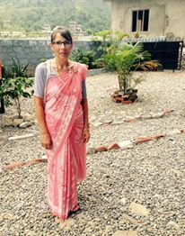  As you know, my mom has been here with me this last month. She has truly been an angel sent by God in more ways than I can count. She has nursed me back to health through fevers and a reocurring stomach flu, been my faithful prayer and worship partner, and my formidable adversary in enumerable games of 'Ticket to Ride' (a board game). She has also been a huge blessing to other 'workers' helping them with cleaning, renovating and garden projects. Our guesthouse has gotten a makeover since she arrived and she has taught the girls a lot about cleaning and caring for things. Everyone calls her 'Aamaa' (mom) and she will be greatly missed.  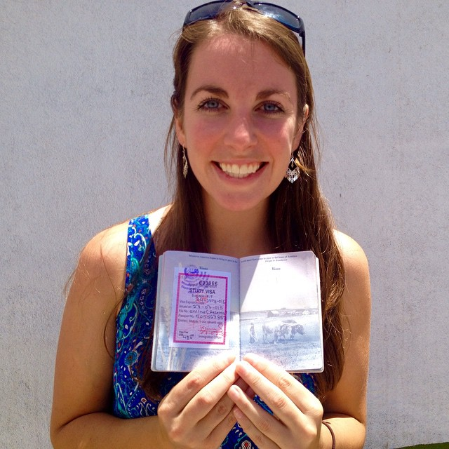  After much effort, I have a 1 year visa to stay in Nepal!!! With the way the system works I shouldn't have to apply for another non-tourist visa for 22 months! I will be assessing villages in two of the most earthquake affected regions in order to provide information on the damages, assistance received and remaining needs. | 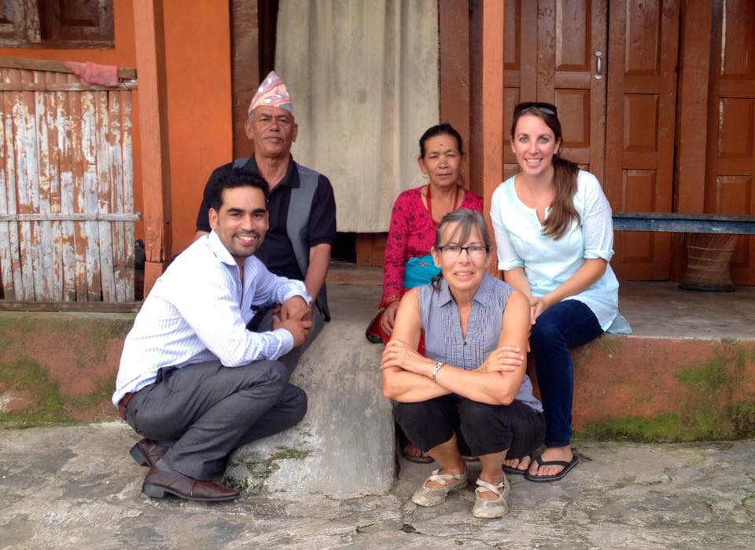  After many failed attempts, I finally made it to my tutor's village to meet his parents. It is always fun to get outside the city limits and observe village life. His parents have very little, but were so hospitable during our visit and served us fresh roasted corn and wheat cakes! I am still praying he would come to Jesus and would love for you to pray with me!  In my own neighborhood, I have had the joy of discovering a few Nepali Christians! I am hoping that together and with the Lord's wisdom and creativity we can be more intentional about reaching out to our other neighbors.  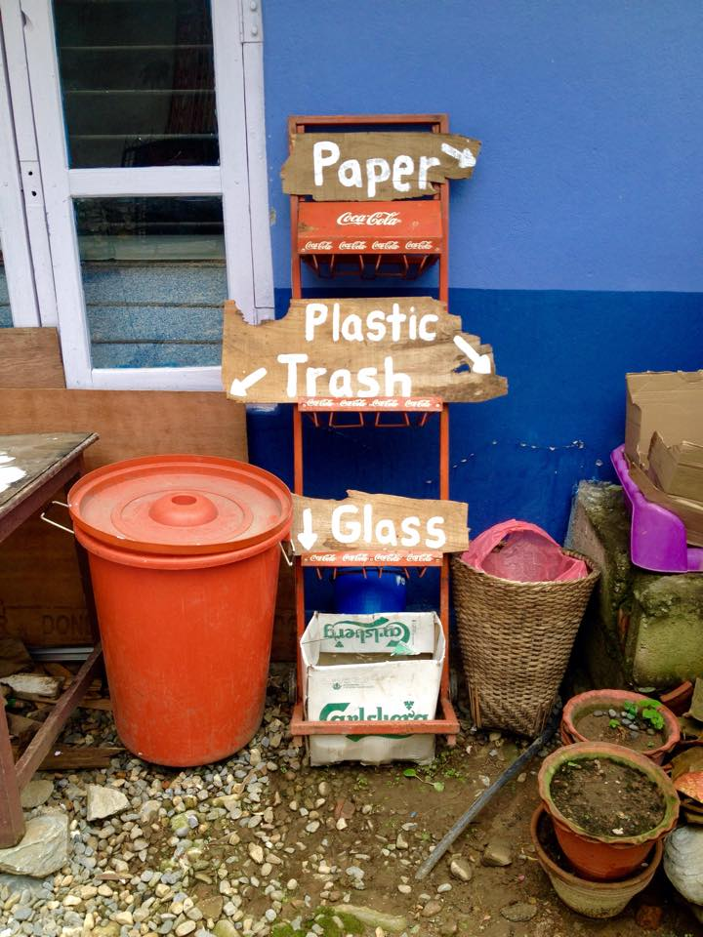  Garbage is a huge problem in Nepal - it is thrown anywhere and if its collected, its often burned. My mom and I got creative to deal with our guesthouse garbage. We came up with a system for sorting the trash, paper and compost, and I called a Swiss recycling factory to start picking up our plastics. I then went around to our neighbors and asked if they would be willing to gather their plastics as well and they said yes! We will see how it works.

Prayer Requests & Updates
- Vision: I am feeling encouraged and have a greater sense of purpose again. Please pray the Lord would continue to give me the determination to press through a more difficult season and release a fresh wave of joy for my work in Nepal.

- Visa: Praise Jesus I have it!! Now on to the research... Pray for connections in the villages and a way to share about Jesus without getting in trouble with the government.

- Health: In general, my sleep has improved and I am able to take less medication. As a result, I have headaches about 1-2 days a week instead of 3-4! Yet, I still wake up each morning exhausted from trying to sleep rather than refreshed. Please continue to pray for total healing!

- Jesus exposure: I am working with a friend and his team to organize and finance another Christian concert in the center of town. Please pray for wisdom and favor as we make decisions and interact with authorities.

- Community: I have made friends with some more Nepali Christians in our neighborhood and been able to meet with them and encourage them, which has been so fun! I would love to see us working together to pray for and reach our neighbors. Pray for wisdom on how to do this!

- The girls: My Nepali girls are doing great! I can see them growing and changing each day. I have been talking to them about sharing Jesus with their friends and family. Please pray they would the motivation and courage to do so!

- Team: I am kind of on my own here in Pokhara. Please pray God would send me fellow workers to partner in ministry and do life with!

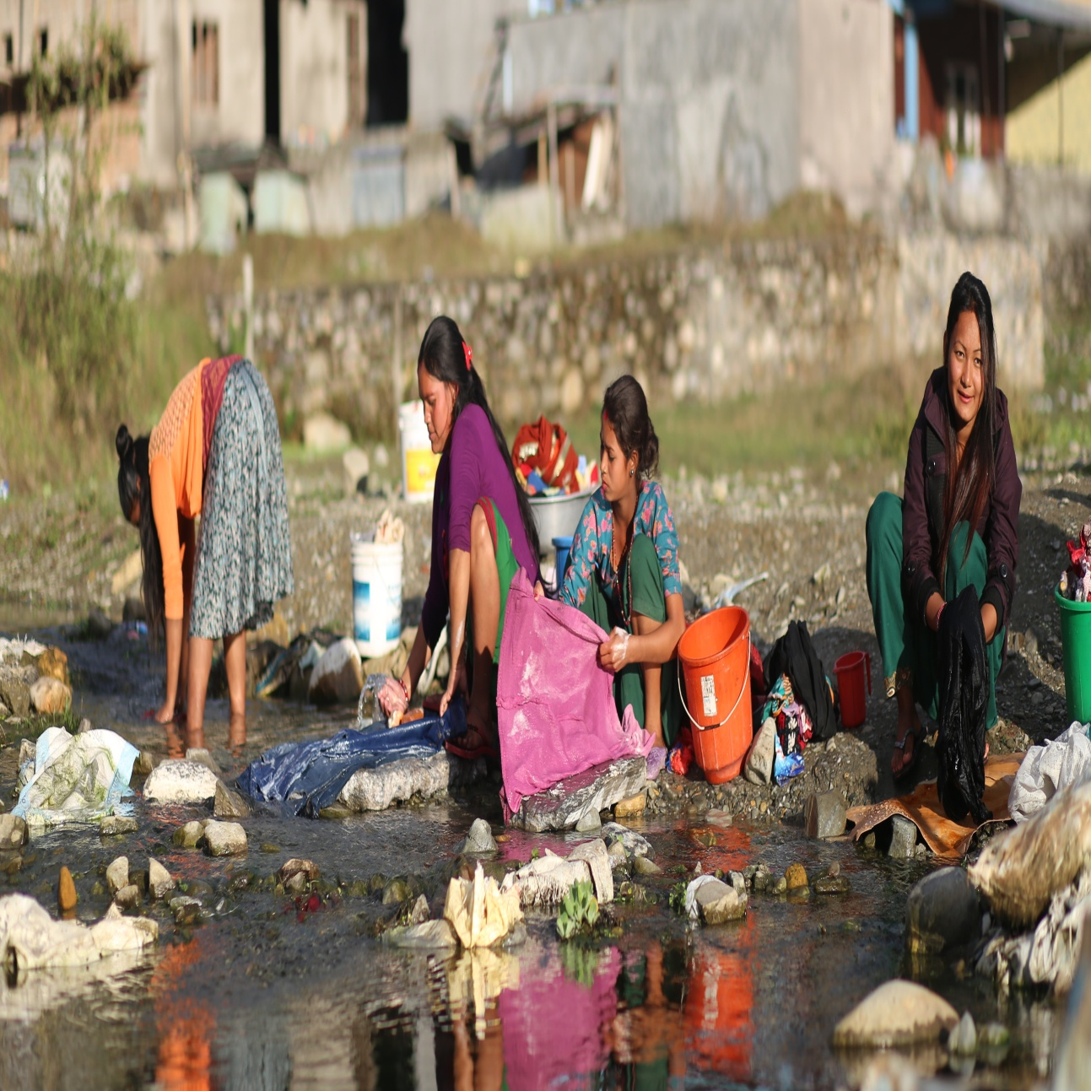

CHANGE TO THE DONATION PROCESS:

My parents church in Washington will now be processing my support.
Since the finance office in Kona charges me a small administrative fee this saves me a little money!

Please make future donations in the following way:
1) Make your check out to: Renton Christian Center or RCC
2) Write my name on the memo: Lindsay Diederichs
3) Send your check to:
Renton Christian Center
16640 SE Old Petrovitsky Rd.
Renton, WA 98058

I still have an active account in Kona, so I will receive anything sent to their office.

***Instruction for automatic monthly deposits to follow.***

To give internationally, please send donations via paypal to:

LDiederichs1987@gmail.com

