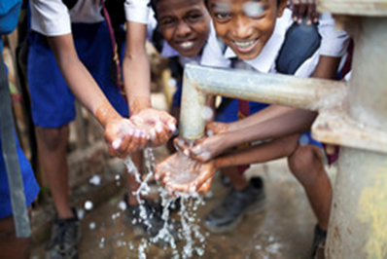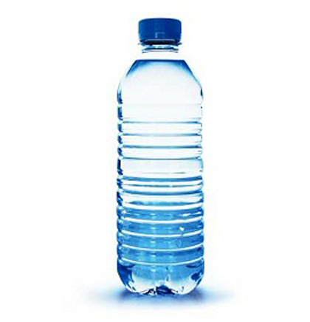

**Saves Lives**

Clean Water Children’s Project

**WaPac GOAL: $6,000**

**Send project money to:**

**WaPac District Office**

**NCM - #ACM1675**

WaPac 2018—2019

CHILDREN’S PROJECT

**Fundraising Ideas**:

◻ Sell bottled water at Youth Group

◻ Organize a two week *beverage fast*—water only

◻ Host a 5-K race

◻ Have a Bake Sale

◻ Walk for Water event

◻ Have a Talent Show

◻ “Rent a Kid” Fundraiser

◻ Pancake Breakfast

**$200 = a child’s clean water**

Clean Water Children’s Project

Almost a billion people are living in our world without clean water. Waterborne diseases, lack of sanitation, and poor hygiene are the leading cause of death. Recent natural disasters in coastal areas of Sri Lanka have resulted in polluted drinking water.

Please be a part of the **WaPac Children’s Project** to collect $6,000 for a biologic water filtration system. This technology will allow pond water to be cleaned for consumption on this island nation in the Indian Ocean.

**Together we can make a difference!**

CLEAN WATER

