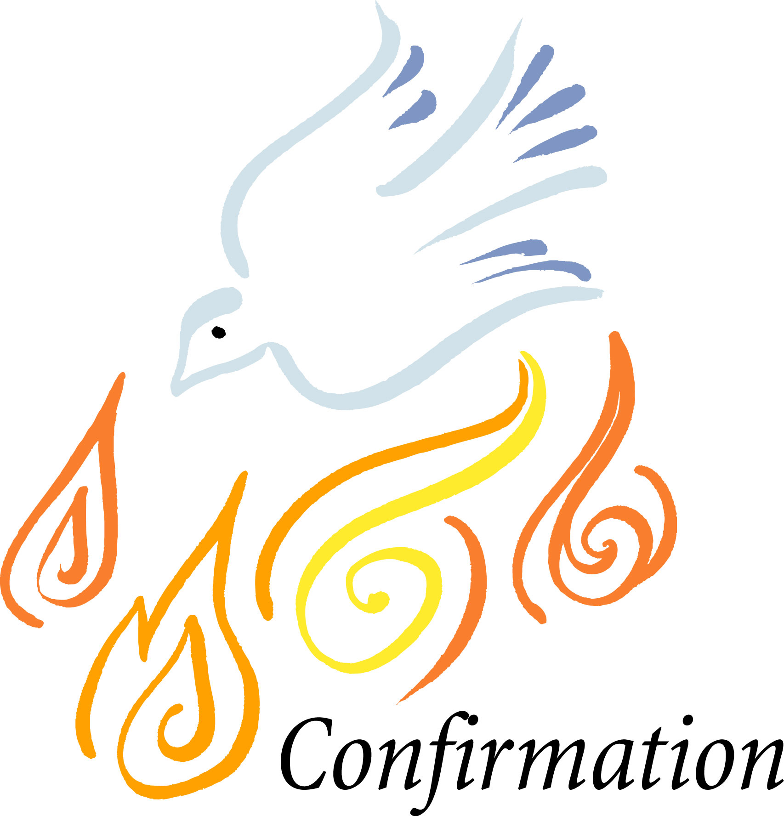

2016-2017

Covenant
Active participation in the class and activities of the confirmation program is vital to preparing for membership and claiming one’s faith. Please read each point of the covenant to understand how it applies to your willingness to make this commitment. After having read the covenant, you are encouraged to declare your commitment by signing below.

1. I will attend worship during confirmation.
2. I will make every effort to attend all classes and to be a part of the field trips that have been scheduled. In the event that I am unable to attend, I will meet with a counselor to become familiar with the material that was covered.
3. I will memorize the Bible verses and creeds by the assigned dates.
4. I will participate in as many activities (retreats, service, field trips) as possible
5. I understand that if I honor this Confirmation Covenant that I will confirmed as a full member of NAUMC on April 23, 2017.

Confirmand’s Signature ___________________________ Date ___________

For Parents:

We will be accountable for the parent’s baptismal vow during the coming year which states: “Will you endeavor to keep this child under the ministry and guidance of the Church until she/he by the power of God shall accept for herself/himself the gift of salvation and be confirmed as a full and responsible member of Christ’s Holy Church?”

I/We will _____________________________________________________________

The events in confirmation require a fee, and assistance is available through the church as well as through fundraisers. Contact Pastor Jean @ 614-855-1403 ext. 8003 or email
Schaferjean75@gmail.com or text: 614-354-6631. Facebook messenger. Jean C Schafer

