- Section 5:
REFUGEES AND NEW IMMIGRANTS

 | Page #
- OVERVIEW | 501
- RESOURCES | 514
- AFFILIATE REPORTS | 519

- OVERVIEW

Engaging Immigration Conference
for Pastors and Ministry leaders
Northwest Nazarene University Wesley Center, August 21, 2014
Attended and submitted by Gary Ip

The objective of this conference is to inform and inspire pastors and ministry leaders as looking at immigration through a Biblical leans. This one day conference consists of two plenary sessions, showing of a film, and a panel discussion with various professional experts on this topic.

The opening session was led by Pastor Ken Wilde, the senior pastor of Capital Christian Center in Meridian, Idaho. In his message, he pointed out immigration is a social political issue for America. As increased immigrants, especially illegal immigrants, arriving US recently, it puts a lot of pressure on the political stage of America. He believes the most effective way to help changing the public policy regarding to immigration starts from congressional members. He and his team had many opportunities to visit individual congressman or congresswoman on a regular basis. Unlike many lobbyists of asking for political favor, their visit was asking if they can pray for and care for these congressional members. Often times, they bless them with God’s word and pray for strength so they can carry on their difficult mission as congressional members. From Pastor Ken’s experience, these visitations touched many hearts and help changing the lives of the congressional members. He found that many of them are Christians but they have constrains and difficulties for exercising their faith and believe in the political environment. These visitations were encouraging and help leading them back to God.

I found this approach refreshing. Although not very many Christian leaders can approach the congressional members like Pastor Ken, we can approach government officials in local level. We can pray for them. We can bring the love of God and blessings by visiting them. Changing the heart of our government officials, or law makers, could result in policy change.

The plenary session was led by Dr. Daniel Carroll-Rodas. Dr. Carroll- Rodas is a distinguished professor of Old Testament at Venver Seminary in Colorado. He is also the author of Christians at the Border: Immigration, the Church, and the Bible.

Dr. Carroll-Rodas’ topic is “The Bible and Immigration: Finding our Moral Compass.” As an American with multicultural background, he brought out a challenge for Christians to think self-consciously. Throughout the Bible, different cultures were mentioned and we can appreciate immigrant as part of our human history and the history of the Bible. He then led us into the scripture and examine how the topic of immigration can be found in both the Old Testament and the New Testament.

Often times when Americans encounter the topic of immigration, we refer it to a political or social issue. However, Dr. Carroll-Rodas help Christians to understand immigration is actually a humanity issue. In the Old Testament, God created human in his own image. In the eyes of God, human’s image and value are extremely high. God values every single one of his creation. The importance of a constructive starting point for immigration is that the immigrants’ humanity is more important than their legal status. Our guiding principle should be the acceptance of immigrant as human rather than what the law on earth says. It does not mean the law of our country is not important or we should welcome immigration even though they are illegal. Our country should fulfill the responsibility to safeguard the boarder. From Biblical perspective, we need to bring hope for the ones who already arrived in this foreign land, the United States of America.

From the experiences of God’s people in the Old Testament, it is not difficult to connect their experiences with the immigrant’s stories. Abram later became Abraham, experienced the pressures at the border. As a result, he had to leave his homeland. Joseph was sold to a foreign land. Although he was assimilated, yet he maintained his cultural identity. Their population had grown tremendously in Egypt caused draconian laws to control their population. Naomi and Ruth had complex process of assimilation. Daniel, Ezra, Nehemiah, and Ester all had different levels of assimilation. Immigration exists not only in today’s world, but in ancient world.

The law of God has specific teaching in handling immigrants. Immigrant from the outside often lack of extended family. They also had problem of land ownership in peasant economy. As a result, immigrants were vulnerable in foreign land. The provisions of the Law helped addressing the vulnerability issue for foreigners such as labor, justice, food, and inclusion in worship. On the other hand, the Law expected the outsider to learn the local language and culture. Israelite as immigrants before, they were reminded by the Law that they once were slave. Therefore they have the responsibility to treat other foreigner respectfully.

Old Testament Law set a good foundation of how immigrants should be treated. It is base out of compassion due to the love of God to mankind. In reflection, the way our law in America need to have a better balance between compassion and punishment for those who enter our country especially who come in illegally.

In the New Testament, immigration had a great connection with Christian mission. The theme of “outsiders” is a key theme in the gospels, and especially in Jesus’ own life and teachings. Jesus’ life on earth started as refugee. He and his family were refugee in Egypt. In his teaching, he focused on the general thrust of his work, the gentiles, and the Samaritans. As the gospel is not only for the Jews, Jesus demonstrated how reaching out to the outsider is important in order to expand God’s kingdom on earth.

From the Book of Acts, Christians scattered to foreign lands through persecution. They form churches and outreach to multiethnic groups. These diaspora churches, with different ethnics groups experienced tensions in congregation thus forcing Christians’ scattering in different regions. In early church, we can see the outreach of the gospel was carried out by apostles like Priscilla, Aqulia, Apollos, and Paul to many geographical locations. Apostle Paul himself was a diaspora Jew from Tarsus as well as a Roman citizen. His mission almost always started out in cities’ synagogues where diaspora Jews could be found.

Here in the U.S., God has brought people from around the world. This makes our country as a new mission field. Instead of sending missionary to foreign lands, there is a need to focus on gospel needs domestically. Finding ways to reach out to these people is a way to expand the Kingdom of God. New immigrants could become partners in mission locally and elsewhere.

Besides having a mind of spreading gospel among new immigrant groups, the Bible has a call for use to charitable hospitality. To serve the least is a way to serve Christ. We are called to love God and love men and helping them in times of need, especially when they first moved to a new country, a new community, and a new culture. As immigration relates to humanity issue, Dr. Carroll-Rodas encouraged Christians in this country to rethink the way we approach new immigrant from the above Biblical point of view.

After the plenary session, we were shown a film “The Stranger”. This documentary film showed us how immigrants exist in our country in some unthinkable ways. There are 11 to 12 million undocumented immigrants living in the U.S. plus a fair amount of immigrants who come in legally. All of these strangers love to be a good citizen and be part of the country. Besides looking at the immigration issue in a political or legal perspective, we need to look at it as human, moral, and Christian issue. Churches are called to love these people. Churches have a responsibility to involve as the Bible tells us to embrace the alien as this is the way to care for the weak and needy.

The film showed a few scenarios for how immigrants can get in hardship in this country whether they enter legally or illegally. These include all lower, middle, and upper classes’ populations. The film pointed out our current immigration law is outdated. These laws do not keep up to the reality due to government bureaucracy. It is not only difficult to obtain legal status in a reasonable way, but these outdated laws affect many people’s family lives in our society.

Families who have members without legal status often live under a shadow. These people are living under fear for deportation thus forced to separation. As Christians, we need to pray for them and support them when they are in the middle of the legal battle. It is important to acknowledge that many of them find Christ in the U.S. Helping our brothers and sisters, as well as our neighbors in these difficult times are what we are responsible for.

The film calls for immigration reform for humane, moral, and ethical reasons. Meanwhile, Christians can advocate for these strangers, and we can educate others to care for them in Biblical way. Immigration in the U.S. is a complex issue and no easy solution. Even so, we believe God move people around the world with purpose. This film could be found on the Internet http://www.thestrangerfilm.org/

After the film screening, there was a panel discussion with question and answer session. Most of the questions concern how Christian can change our view of immigration from a legal and political perspective to humane, moral, and biblical perspective. How can churches help immigrant population around their area of service. Dr. Carroll-Rodas pointed out that one of the ethical issue we need to aware of is that in the current system, the society wants undocumented immigrants’ labor, but the society does not want them as human. This is a strong reminder for Christians to pray for justice for these strangers.

The entire conference to me is both informative and reflective. I pray that as God open my eyes to see the needs for caring new immigrants, I would be able to share what I have heard and learn to other Christians so they can join in effort and prayers in this area of need in our society.

B. RESOURCES

RECOMMENDED READING LIST FROM DAN SAMUELSON

A Long Way Gone. (Ishmael Beah)—First hand account of young child soldier from Sierra Leone who was rescued by UNICEF and is now a member of the Human Rights Watch Children's Rights Division Advisory Committee.

Alek: My Life from Sudanese Refugee to International Supermodel—(Alek Wek) Young refugee fled to England and tells her life and how she became a supermodel

Andy Grove: The Life and Times of an American—(Richard Tedlow) A story of how a middle-class Jewish man fled to New York and succeeded in the United States. He became Intel's president in 1979 and CEO in 1997.

Artists in Exile: How Refugees from 20th Century War and Revolution Transformed the American Performing Arts—(Joseph Horowitz) Case study of several Russian and European performers who emigrated to the United States during the 20th Cetury.

Asylum Denied: A Refugee's Struggle for Safety in America—(Philip G. Schrag) A story of a man who fled to the United States from an execution in Kenya. It explains how the immigration system works and suggests reforms that are needed in order to help victims of human rights violations.

Buddha is Hiding: Refugees, Citizenship, the New Americans—(Aihwa Ong) Cambodian refugees arrive in the United States, fleeing the murderous Pol Pot regime. It describes how these refugees worked through day to day life such as welfare, work, medicine, parenting, etc; yet, they are trying to hold onto values of family and their home culture.

Children of War: Voices of Iraqi Refugees—(Deborah Ellis) The author has interviewed several Iraqi refugees who have been a part of the war in Iraq. Their stories help humanize the war and give an idea of the everyday lives of citizens who must cope with the immediate and long-term effects of war.

Coming Home? Refugees, Migrants, and Those Who Stayed Behind—(Lynellyn Long and Ellen Oxfeld)This book is about refugees who have gone back to their homeland after years of living in a different country. This can benefit their homeland with new resources.

Courageous Journey: Walking the 'Lost Boys' Path from Sudan to America—(Barbara Youree) a mentor for two Sudanese boys in college, tells the story of how they walked for hundreds of miles through Sudan during war-time and how they were walking towards their dream in the United States.

Escaping North Korea—(Mike Kim) A missionary who escaped North Korea. He gives an inside look into the hidden world or ordinary North Koreans. He tells of first-hand accounts of famine, women's sex trafficking, torture and inspirational stories of refugees who overcame tremendous adversity.

First they Killed My Father—(Luong Ung)The author tells of her time during the Khmer Regime and how her and her family were forced to flee. Her and her brother eventually flee to Thailand and then to the United States.

Global Changes in Asylum Regimes--(Daniele Joly) This book brings up questions about asylum in different countries—just an overall indepth look at asylum topics.

God Grew Tired of Us: A Memoir--(John Bul Dau and Michael S Sweeney) A look at four boys from Sudan who were resettled by the Catholic Charities in the United States.

Good Scent from A Strange Mountain--(Robert Olin Butler) The author of this book captures the voices of people who have lost their homeland and are trying to adapt to an alien culture in New Orleans.

Healing Invisible Wounds: Paths to Hope and Recovery in a Violent World--(Richard F. Mollica) The author is the director of the Harvard Program in Refugee Trama. He explains how refugees should be allowed to tell their stories in their own way. He endorses contemporary neuroscience and ancient/non-western healing practices.

Hmong in Minneapolis--(Chia Vang) Author reveals the history of Hmong Minnesotans, many of whom were forced to flee their homeland of Laos. She explains how they adjusted to life in the United States. One girl tells her story of how she was resettled by Catholic Charities in 1976.

Homecomings: Unsettling Paths of Return--(Fran Markowitz) This book explores the forces and motives that drive immigrants, war refugees, political exiles and their descendants back to the places of origin.

I Live Here--(Mia Kirshner) It is a set of books, each based around journals the author kept. She interviewed women and children in countries and cities that are affected by violence, disease, war, and ethnic cleansing. The stories illuminate the lives of people living in Checnya, Burma, Mexico and Malawi.

Kite Runner--(Khaled Hosseini) This is a story of a young Afghani boy who eventually escapes to California with his family. It describes how this young man adjusts to life in the United States.

Landscape of Hope and Despair: Palestinian Refugee Camps---(Julie Peteet) Stories of refugees who lived in refugee camps in Lebanon. It is a story of the struggle to recreate their place and identity and add meaning to their surroundings through the use of culturre and memory.

Little Daughter: A Memoir of Survival in Burma and the West--(Zoya Phan and Damien Lewis) Zoya spent her years growing up in Burma. She was awarded a scholarship in London and then began telling her story.

Lost Boys of Sudan—(Mark Bixler) Orphan boys who walked across Sudan to find help from refugee camps. Many of them were resettled in the United States

No Dream Beyond My Reach: One Woman's Remarkable Journey from Cambodian Refugee to American MD--(Sopheap Ly) Encouraging story of a young girl who spent more than 10 years as a child slave under the Khmer Regime and then refugee. Despite all odds, she perseveres to become an American doctor.

Nuer Journeys, Nuer Lives: Sudanese Refugees in Minnesota--(Jon Hotlzman and Nancy Foner) This book examines contemporary migration to the United States through a surprising and compelling case study.

Of Beetles and Angels: A Boy's Remarkable Journey from a Refugee Camp to Harvard--(Mawi Asgedom) Mawi shares his personal story of being a refugee from Sudan and his travels to America. He eventually got a full tuition scholarship to Harvard.

Problems of Protection--(Niklaus Steiner) This book explores the problems that occur with refugee assistance when organizations try a simple fix, it can quickly become complex and complicated.

Protracted Refugee Situations--(Gil Loescher, James Milner, Edward Newman, Gary Troeller) It considers the causes and impact of the refugee crisis and exposes the consequences that we face. It also gives some ideas that should be considered in the future.

Refugee Women--(Susan Forbes Martin) The author draws on years of experience on personal field experience and policy work. In her book, Susan brings up the particular issues faced by women driven from their homes as a result of international conflict. She also discusses the issues of women who are displaced in their home countries.

Refugees in a Global Era--(by Philip Marfleet) This book is an analysis of forced migration in the age of globalization. It explores histories of migration, the changing patterns of migration and the refugee experience of displacement, flight and the search for asylum. Critical reading for all students seeking to understand the position of refugees today.

The Bite of the Mango--(by Mariatu Kamara and Susan Mcclelland) Mariatu grew up in Sierra Leone abd at the age of 11 watched as soldiers torture and kill those around her. This book is Mariatu's story of how she left Sierra Leone and found refuge in Canada. She is now a UNICEF representative.

The Day of the Pelican--(by Katherine Paterson) 13 year old Meli's life changes forever (ethnic Albanian) after her brother escapes his Serbian captors and the entire family flees from one refugee camp to another until they are able to immigrate to America.

The Empire of Trauma: In Inquiry into the Condition of Victimhood--(by Didier Fassin, Richard Rechtman, and Rachel Gomme) This book offers an understanding of the anthropology of the concept of trauma and also discusses the development of values and the value systems in our globalized world.

The Land of the Green Ghosts--(by Pascal Khoo Thwe) Pascal miraculously ends up leaving Burma and is enrolled in Cambridge University. This book evokes the realities of life in modern-day Burma and tells one man's journey despite almost unimaginable odds.

The Price of Indifference--(by Arthur Helton) Helton looks at the controversial and politically pressing issue: refugee policy. He analyses refugee policy responses over the past decade.

They Poured Down Fire on Us from the Sky--(by Alphonsian Deng, Benson Deng, Benjamin Ajak, and Judy A. Benstein) This is a story of three boys who traveled more than 1000 miles throughout Sudan, relocating to Kakuma Refugee camp and eventually making it to the United States as part of an international refugee relief program.

To Be a Friend Is Fatal--(by Kirk W. Johnson) The fight to save the Iraqis America left behind

UNHCR: The Politics and Practice of Refugee Protection in the 20th Century--(by Gil Loescher) A short study was done of the history of the UNHCR and the tensions between the agencies humanitarian agenda and the interests of the state. This book describes the results.

What is the What--(by Dave Eggers) A Sudanese refugee who tells the story of his journey from war torn Sudan to Atlanta, Georgia.

Welcoming the Stranger--(by Matthew Soerens and Jenny Yang) Justice, Compassion and Truth in the Immigration Debate

When Broken Glass Floats--(by Chanrithy Him) A young girl in Cambodia, describes the terror and losses she suffers under the Khmer Rouge. She now lives in Eugene, OR where she works for the Khmer Adolescent Project studying post-traumatic stress disorder among Cambodians.

Where the Rivers Meet: A Tibetan Refugee Community's Struggle to Survive in the High Mountains of Nepal--(by Clint Rogers) The remarkable story of the Samdo refugee community's struggle to survive and hold on to their traditional way of life in the face of political, economic, and physical challenges.

White Pearl and I: A Memoir of a Political Refugee--(by Svetlana Kim) The story of a young Russian who escapes to the United States and eventually becomes a stockbroker.

C. AFFILIATE REPORTS

CULTURAL COMPANIONSHIP, PROGRAM OF WORLD RELIEF/SEATTLE
I am a “cultural companion” of a family recently arrived as refugees.

As a cultural companion with World Relief I meet up with them weekly to help them assimilate into American life and culture. On Monday they moved from Kent to Seatac with the help of one of our church's college age students. Uzias helped them drive the Uhaul from Kent to their new apartment in Seatac because they don't yet have their drivers licenses. That is our next major goal -- passing the drivers test!

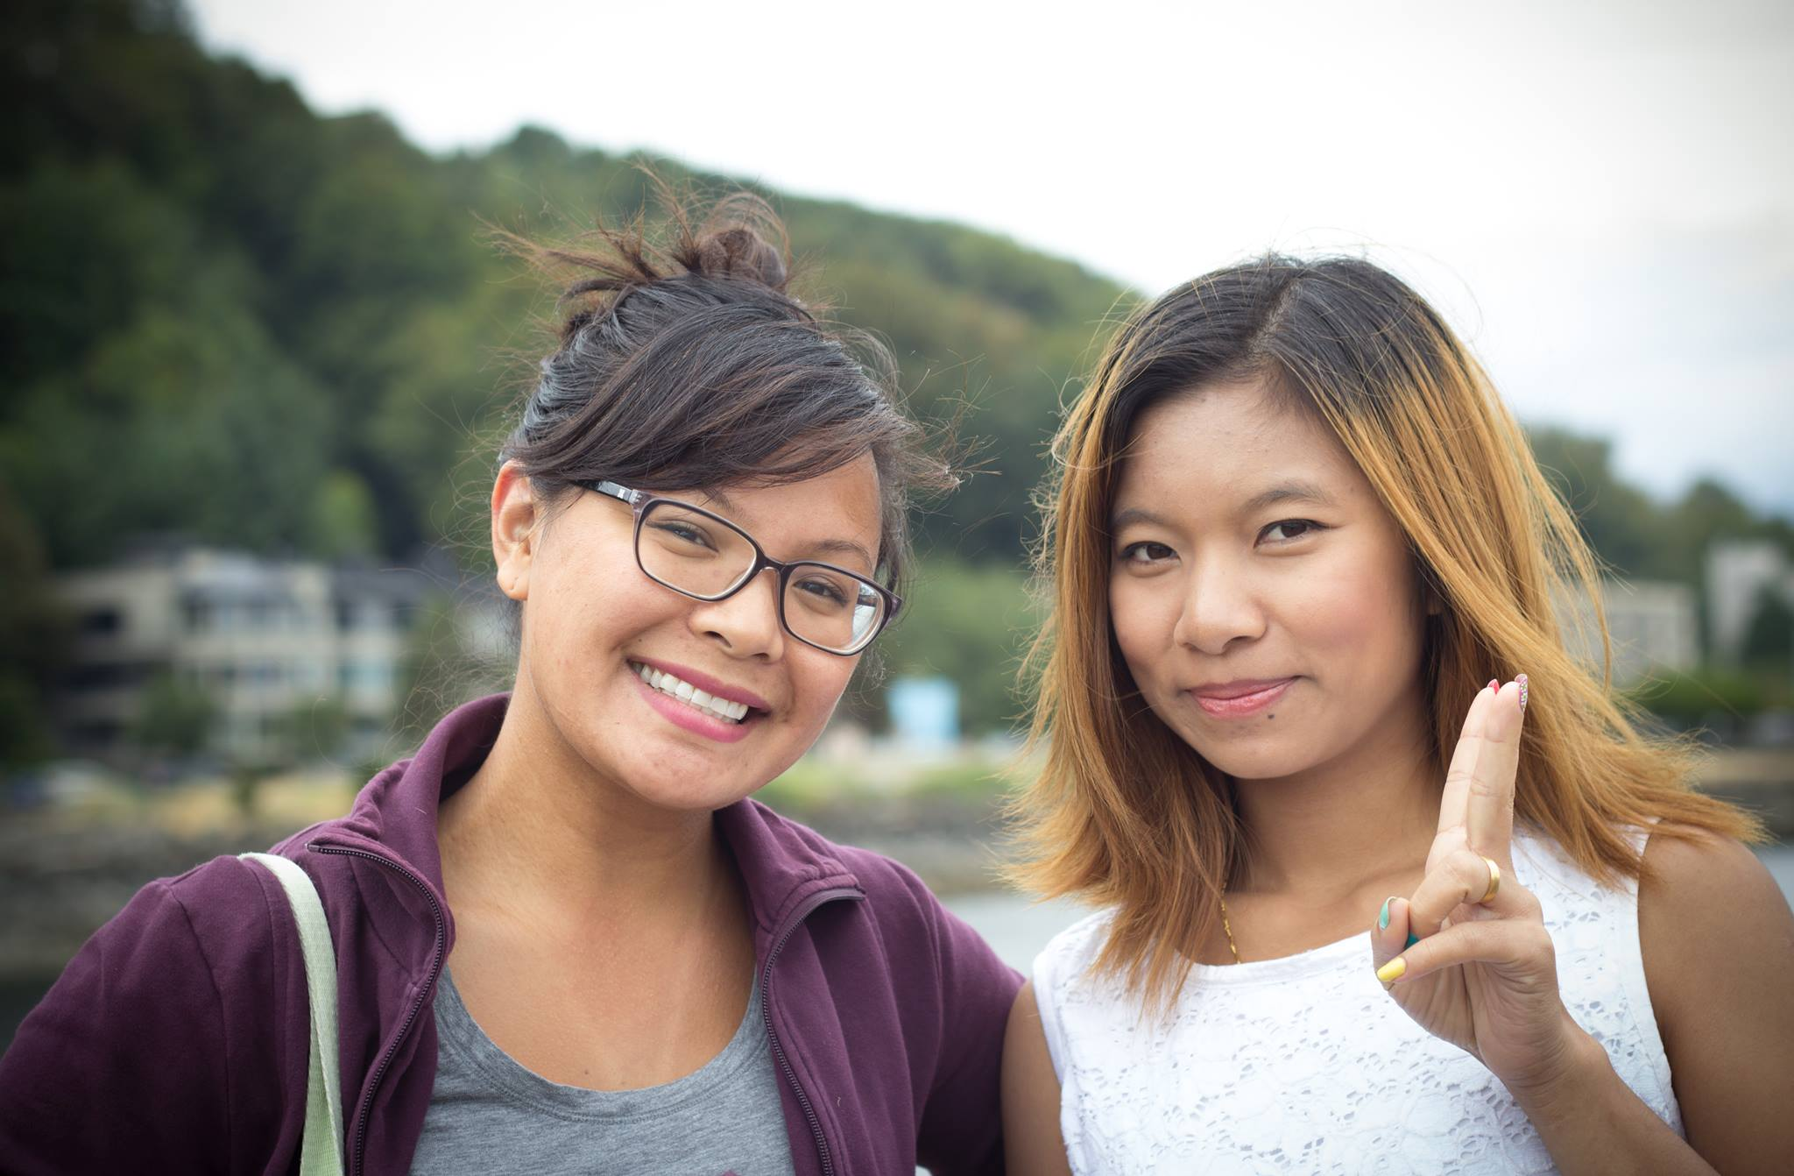

The photo is of me with Mai Ley. Her daughter is Thien Uap, Mai's husband Salai is an aspiring photographer and took our pictures. He has good equipment that he brought with him from Malaysia. Although they are originally from Burma (Myanmar) and are here in South Seattle as refugees.

http://worldrelief.org/page.aspx?pid=2819 This is a link to the cultural companion page on World Relief's site -- just a reminder of why we have them as Strategic Partners -- so great to know they are helping us as we help those in our communities. We are excited that today Dan Samuelson is meeting with our Renton church to see about possibilities there. Please pray for this time.
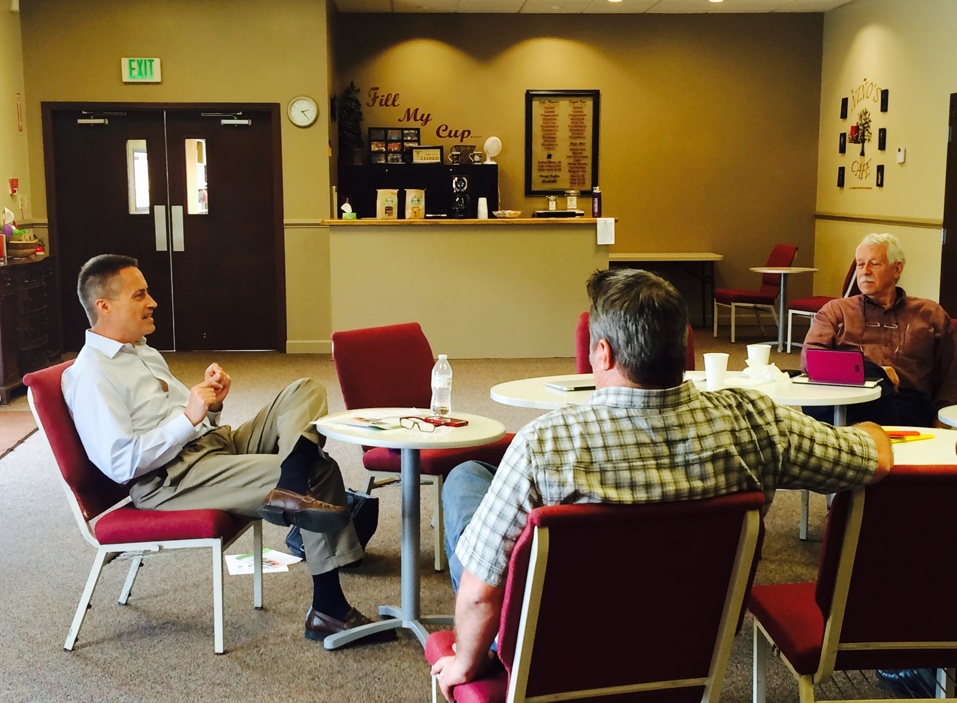

If you think about your church and what they are doing to extend the compassion of Christ to the community they are in I'm sure you can find moments to share with others on our website of the good things that are being done all around our district.

Regina Conlon

