Non-Discrimination Policy
Shepherd of the Ridge Lutheran Preschool does not discriminate in the administration of educational policies, admission policies, or any school program with regard to race, color, religion, sex, national origin or disability.

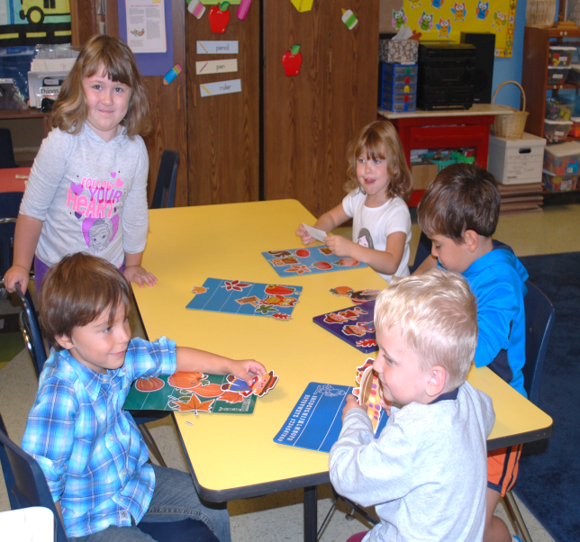

Who We Are

About Us
Classes are designed for children ages 3 and 4. A Pre-Kindergarten class is also available.
Our preschool is licensed and inspected annually by the Ohio Dept. of Job & Family Services.
The program is a ministry of Shepherd of the Ridge Lutheran Church. As such it is governed by the Board of Preschool Ministry of the congregation.
Contact Us
Phone: 440-327-1032
Email: preschool@shepherdoftheridge.org
Web: shepherdoftheridge.org

Shepherd of the Ridge Lutheran Church
Sunday Worship 11:00 AM
440-327-7321

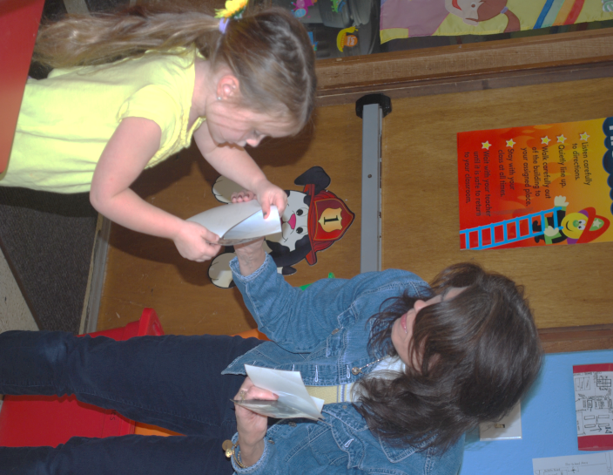
SHEPHERD OF THE RIDGE LUTHERAN PRESCHOOL
34555 Center Ridge Road
North Ridgeville, Oh 44039
440-327-7321
440-327-1032

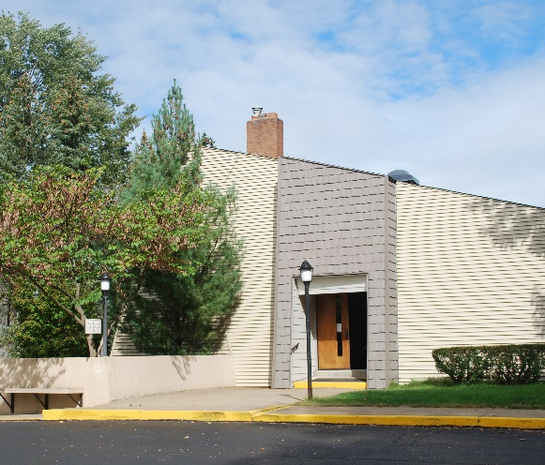

Our Mission
God has created every child with unique and gifted potential to serve Him in His creation. We strive to provide a Bible-based foundation of learning and development that will set children on a Christian way of living and equip them to function in the world with integrity, compassion, and skill.
Preschoolers develop at an astounding pace in so many ways. It is in these early years that patterns, attitudes, personalities, and abilities emerge and influence the child’s later years.
Effective guidance and teaching during these early years must involve the total child. Our goal is to assist parents in the guidance of their child as he/she matures intellectually, emotionally, socially, physically, and spiritually.

Goals and Objectives
The Ohio Department of Education has issued the Early Learning and Development Standards which set forth key concepts and skills that young children develop during the birth-to-five-year period. The standards provide a comprehensive and coherent set of expectations for children’s development and learning. We utilize the standards as a guide for designing and implementing the curriculum and the day-to-day instructional methods used in the classroom.
- Time with Jesus:
Bible stories and application of their truths will help children develop a close and on-going relationship with God.
- Language and Literacy Development
Children will be introduced to stories, poems, finger plays, etc., through the use of books, dramatic play, and multi-media.
- Cognitive Development & General Knowledge
Children will learn to use tools such as scissors, crayons, pencils, paper, books, etc. They will also be introduced to math, science, and social studies.
- Physical Well-Being & Motor Development
Activities and materials are utilized to help children improve coordination and body awareness.
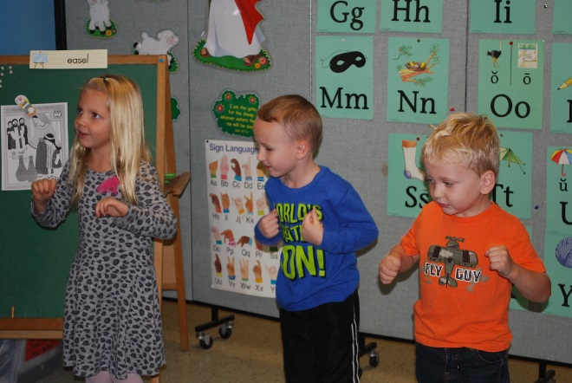
Enrollment Information
Enrollment for the school year begins in late January.
For specific information about the program and the enrollment procedure call the preschool to make an appointment with the Administrator. 440-327-1032
Enrollment is on a first-come first-reserved basis. No class positions are held until the enrollment fees and documents have been received.
